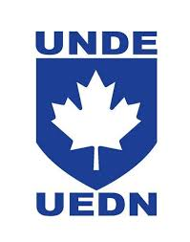


RPOU Regional Report
VP QC

Here is my report on the Real Property Operations Unit (RPOU) of Québec from February to November 2020:
We had two UMCCs via Teams with LCol Nith. We always have frank discussions with the RPOU, which facilitates the work between the parties. The availability of LCol Nith ensured that disputes could be resolved more efficiently. Because of the pandemic, we needed a conference call, and it was effective.

In solidarity,

Michel Allard
VP Quebec

