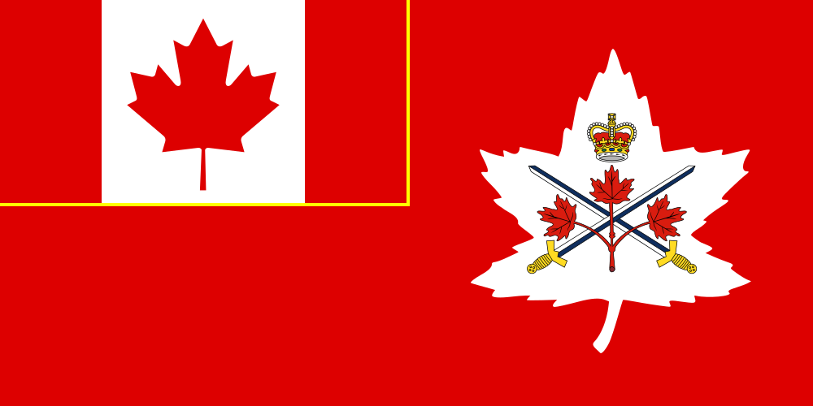

February 2020 Report 2 CDSG - Quebec

We will be holding our UMCC, exceptionally, on January 28, 2021.

Respectfully submitted by

Michel Allard
VP Quebec

