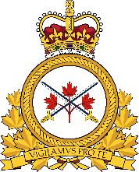COMMANDER OF THE ARMY LMCC

Meeting has been postponed and a new date is being confirmed.

Respectfully,
Daniel Frost
Beniot Laberge

VP NL/NB

