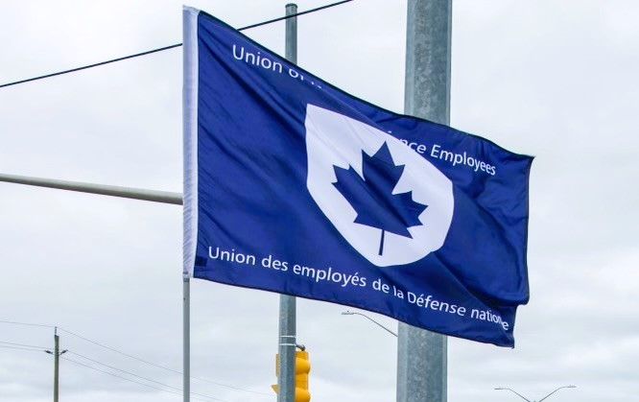

Ontario Region Report – November 9, 2022

The Ontario region is composed of 12 Locals:
00619, 00620, 00621 – Borden
00623 – London
00625, 00649 – Toronto
00629, 00639 - Petawawa
00635 – North Bay
00637, 00650 – Trenton
00641 – Kingston
~ 2,800 members in the region

VP Ontario: James Potts VP Ontario
DVP Ontario: Jayne Pollock
List of Activities since May 2022
- May 25 – UNDE Caucus for PSAC Nation Convention (virtual)
- May 26 - June 3 – PSAC National Convention (virtual)
- June 16 – Standing Bylaws Committee meeting (virtual)
- June 16 – Local 00641 special meeting to discuss finances
- June 23 – NHSPC meeting (virtual)
- July 13 – Established UNDE VP Ontario Facebook profile
- July 14 – Family event in Petawawa, Ontario with Local 00639
- July 18 – PSAC Organizing course focused on Dexterra cleaning contract in Kingston, ON
- July 19 – Established the UNDE Ontario Facebook group
- July 22 – 00637 Trenton BBQ
- July 23 – Established the UNDE Young Workers Facebook group
- Aug 3 – Disciplinary hearing with Local 00641
- Aug 16 – Local 00639 Petawawa Information Picket
- Aug 18 – RPOps Ontario Meeting (virtual)
- Aug 29 – Toure BBQ in Petawawa, Ontario
- Aug 30 – PSAC Bargaining Rally in North Bay, Ontario
- Sept 1 – 00637 Trenton BBQ
- Sept 5 – Labour Day event at Skeleton Park (McBurney) in Kingston, Ontario
- Sept 15-18 – UNDE Ontario Regional Conference in Kingston, Ontario
- Sept 16 – Rally for a Fair Contract, MP Mark Gerretsen’s Office, Kingston, Ontario
- Sept 24 – Trauma Informed Representation Course (rescheduled)
- Sept 28 – In-person meeting with RPOps Ontario CO, LCol Dempsey
- Sept 28 – Rally for a Fair Contract, Collins Bay Institution, Kingston, Ontario
- Oct 5 – Rally for a Fair Contract, MP Mark Gerretsen’s Office, Kingston, Ontario
- Oct 16 – Standing Bylaw Committee meeting (virtual)
- Oct 18-20 – NHSPC meeting in person (Ottawa)
- Nov 3 – Disability Management Consultation Committee (virtual)
- Nov 4 – Rally in support of CUPE Education Workers, Kingston, Ontario
- Nov 4 – Local 00650, hybrid – VP attended in person
- Nov 13-19 – UNDE National Executive Meeting in person (Ottawa)
Issues:
RPOps vacancies and contracting continue to affect several Locals (see RPOps Ontario Report).
Staffing issues continue. Many of these concern nepotism, conflict of interest, ex-military hires, and external non-advertised processes. Some complaints have been filed formally while others are immune from recourse due to the limited scope of the job advertisement or the nature of the process itself.
Retuning to the workplace is being encouraged by managers across the region even though a hybrid posture is the future of many jobs. There is a clear disconnect between DND and several other departments in the application of the new hybrid work policies. People are leaving DND in order to take a position with departments who offer more flexibility, including 100% work from home as an option. As work/life balance has risen to prominence in as a result of the pandemic, we need to ensure that pressure is applied to the department, lest we risk losing much of our membership to other governmental departments.
Cohesion between Locals continues to increase across the region. I remain very positive about the future of not only the Region, but of UNDE as a whole. It has also become quite clear that the role of Regional Vice President should be a full time position.I was honoured to be chosen as the point of contact for French language media interviews regarding the Mme Louise Arbour report. I read the report and prepared detailed speaking notes. I also spoke with a representative from the Canadian Labour Congress concerning the messaging the union would like to adhere to. Unfortunately, I was never contacted for an interview or statement.
UNDE Ontario Regional Conference
After many hours of planning, including a complete change of venues, the UNDE Ontario Regional Conference was a major success. It was held in Kingston, Ontario at the Courtyard Marriott Hotel. Based on feedback from some Local Presidents, the schedule was packed with numerous topics of shorter duration. The schedule went as follows:
UNDE Ontario Regional Conference Agenda

Thursday, September 15 | Activity | Speaker/Guest/Other
All Day - Check-in 3pm | Participants Arrive at the Marriott Courtyard in Kingston, Ontario | 86-60 Dalton ave, Kingston  https://www.marriott.com/en-us/hotels/ygkcy-courtyard-kingston-highway-401-division-street/overview/
1900 - 2000 | Meet and Greet: Boston Pizza | 95 Dalton ave, Kingston https://bostonpizza.com/kingston-east

Friday, September 16 | Activity | Speaker/Guest/Other
0800 - 0815 | Welcome Message: VP Ont, DVP Ont (15 min) | James Potts and Jayne Pollock
0815 - 0840 | Ice Breaker (25 min) | James Potts
0840 - 0910 | Meet and Greet with UNDE LROs Lisa Greenspoon and Louis Bisson (30 min) | Virtual - Lisa Greenspoon and Louis Bisson
0910 - 0920 | Break (10 min) | ******************
0920 - 1020 | Mobilization Strategy/Planning with PSAC (60 min) | PSAC RO MaryAnne Laurico
1020 - 1050 | PSAC AEVP Alex Silas (30 min) | PSAC AEVP/VP NCR Alex Silas
1050 - 1100 | Break (10 min) | ******************
1100 - 1200 | Address and Q&A with UNDE President June Winger (60 min) | UNDE National President June Winger  Virtual - Paul Jones
1200 - 1330 | Lunch (1 hr 30 min) | ******************
1330 - 1345 | Energizing Activity (15 min) | James Potts
1345 - 1430 | Roles of Local Officers (45 min) | James Potts
1430 - 1440 | Break (10 min) | ******************
1440 - 1455 | Address (15 min) | Jessie Lavergne
1455 - 1540 | Address and Q&A with PSAC NEVP Sharon DeSousa (45 min) | PSAC NEVP Sharon DeSousa
1540-1700 | Mobilize at Liberal MP Mark Gerretsen’s Office (60 min) | ******************
1745 - | Dinner – Amadeus Café | 170 Princess st, Kingston, https://www.facebook.com/schnitzelman1/
Open until midnight | Karaoke at 560 Legion | 734 Montreal st, Kingston

Saturday, September 17 | Activity | Speaker/Guest/Other
0800 - 0815 | Energizing Activity (15 min) | James Potts
0815 - 0915 | Contracting-In / Anti-Privatization (60 min) | PSAC RO Tim McIntyre
0915 - 0925 | Break (10 min) | ******************
0925 - 1025 | Contracting-In / Anti-Privatization con’t (60 min) | PSAC RO Tim McIntyre
1025 - 1035 | Break (10 min) | ******************
1035 - 1135 | Open Forum to Discuss Local/Regional Issues (60 min) | Submit agenda items or speak during round table
1135 - 1305 | Lunch (1 hr 30 min) | ******************
1305 - 1320 | Energizing Activity (15 min) | James Potts
1320 - 1400 | Open Forum to Discuss Local/Regional Issues con’t (40 min) | Submit agenda items or speak during round table
1400 - 1450 | Bargaining Updates | Virtual -  TC: Danielle Poissant  SV: Mona Simcoe  PA: Charito Humphreys
1450 - 1500 | Break (10 min) | ******************
1500 - 1545 | Upcoming Activities and Events (45 min) | HR - Brian Harrison  H+S - James Potts  Presidents’ Conference  UNDE Triennial Convention
1545 - 1600 | Wrap Up and Adjournment (15 min) | James Potts
1730 - | Dinner – The Greek Islands | 331A Bath Road, Kingston  https://www.thegreekislandskingston.ca/

Sunday, September 18 | Activity | Speaker/Guest/Other
0800 - | Group Breakfast - Denny’s | 33 Benson st. Kingston,  https://www.dennys.ca/restaurant/ontario/kingston-benson-street/
All Day - Check-out 12pm | Participants Depart the Marriott Courtyard | ******************

The Meet and Greet served its purpose to break the ice prior to the commencement of the conference. Though originally scheduled for an hour, it ended up starting much earlier and ending much later. This was a great start to the conference. There were also a series of “energizing activities” which turned out to be fun exercises. Planning optional large group dinners proved to be an excellent idea. The goal was to build cohesion and camaraderie, and this was certainly achieved.
UNDE EVP Paul Jones joined us via Zoom to observe a portion of Day 1 activities.
The conference also included a rally in support of fair bargaining in front of Liberal MP Mark Gerretsen’s office on Princess st. We were joined by members of other PSAC component Locals and, with the help of UNDE National President June Winger, REVP NCR Alex Silas and NEVP Sharon DeSousa, traffic was blocked and the police arrived on scene. Whether you have heard the stories or seen the many photographs, please note that Kingston knows how to rally!
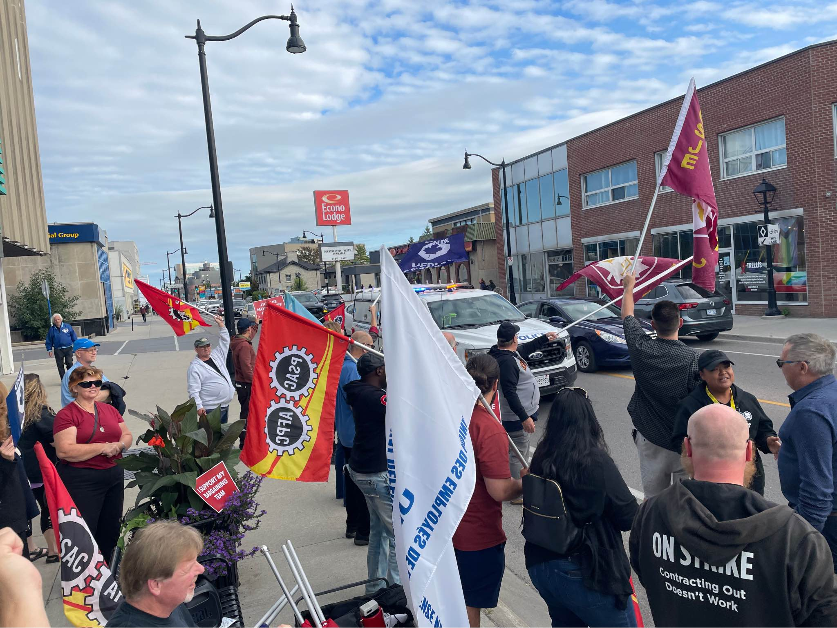
Photo: Rally at MP Mark Gerretsen’s Office (after the police arrived), September 16, 2022.
We received a virtual bargaining update from TC and Common Issues BT Member Danielle Poissant, SV BT Member Mona Simcoe, and PA BT Member Charito Humphreys.
Unfortunately, two Locals did not attend, though they had originally confirmed their intention to participate.
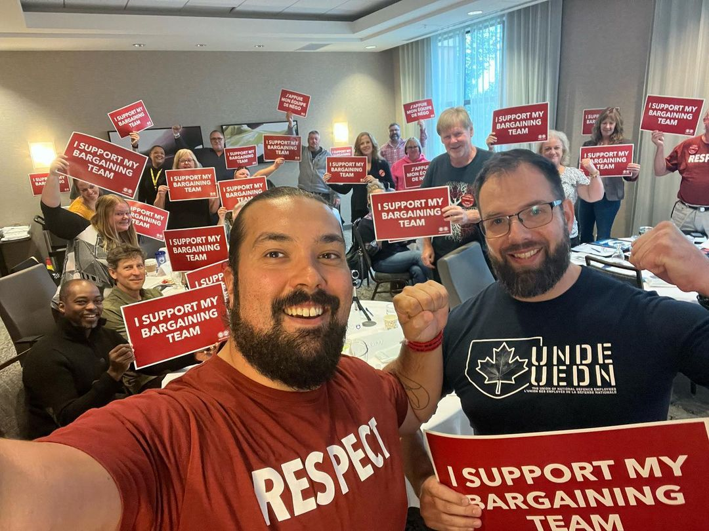
Photo: UNDE Ontario supports Bargaining Teams, Kingston, Ontario, September 16, 2022.
DVP Sister Jayne Pollock has taken on the task of getting Local 00635 back on track as she is located much closer to North Bay, Ontario than I am. The Local Executive was seemingly engaged in restoration on union activities after a lengthy hiatus but now appears to be defunct. Should this issue persist, the Local shall be placed in trusteeship.
Virtual meetings for the Ontario region have begun. There have been 3 meetings so far and all Local Executives and Stewards are welcome to attend. These meetings provide an opportunity to connect and discuss issues and strategies across the region
I have participated in meetings of the Standing Bylaw Committee (SBC) (see SBC report), the RPops Ontario LMCC (see RPOps Ontario report), the National Health and Safety Policy Committee (NHSPC) (see NHSPC report), and the Young Workers Committee (see Young Workers report). I have also participated in numerous meetings regarding the UNDE Labour Relations Officer Selection Process, which resulted in the hiring of two exceptional candidates. I appreciate being a part of this endeavour and the Ontario region is very pleased with their new Labour Relations Representative. Most recently, I have taken on the role of Co-Chair of the Disability Management Consultation Committee, which has just been stood up as a replacement to the Return to Work Committee (see Return to Work report).
Upcoming Activities
- Nov 15 – Local 00625 AGM, Hybrid – VP to attend virtually
- Nov 22 – Locals 00629 and 00639 AGMs, in person – VP to attend
- Nov 28 – Local 00637 AGM, hybrid – VP to attend in person
- Nov 29 – Local 00641 AGM, in person – VP to attend
- Dec 1 – Local 00623, Hybrid – VP to attend in-person with National President
- Dec 7 – Local 00649 AGM, hybrid – VP to attend in person with EVP
- Dec 7 – Locals 00619, 00620, and 00621 AGMs, in person – VP to attend with EVP
- Dec 8 – Local 00635 AGM, in person – VP to attend with DVP and EVP
- Jan – PSAC National Health and Safety Conference in Montreal, Quebec

Respectfully submitted,
James Potts

