
Health and Safety Report: James Potts/Gérald Grenon

The National Health and Safety Policy Committee (NHSPC) held a virtual meeting on February 9th, 2023. The next meeting is scheduled for June 7th, 2023, and will be offered in a hybrid format.
There are 6 working groups that report to the NHSPC. These are the Workplace Assessment, Harassment and Violence Prevention, Hazardous Occurrence Investigations, Psychological Health, Training, and Committees and Governance. There is also a Return-to-Work Committee which will be re-established, and a Safety Program Development and Evaluation Technique (SPDET) Review Working Group is being stood up in June 2023, and James Potts will serve as the Employee Representative.
The Workplace Harassment and Violence Prevention Working Group met virtually on January 24th, 2023. The policy has been receiving thorough scrutiny in order to ensure that any new iteration will be suitable while respecting Gender-Based Analysis+ (GBA+) guidelines.
The Disability Management Consultation Committee met virtually on February 8th, 2023. It was discussed that the language in the “options letter” is certainly indelicate and needs to be reworked to avoid causing further damage to a member who is already dealing with an especially stressful situation. (see Return-to-Work report: addendum to this report).
Training statistics:
General Safety Individual Course (GSIC) – 62,000
Workplace Hazardous Materials Identification System (WHMIS) – 52,000
General Safety Supervisor Course (GSSC) – 19,000
General Safety Officer Course (GSOC) – 2,500
Health and Safety Committees Course (HSCC) – 7,500



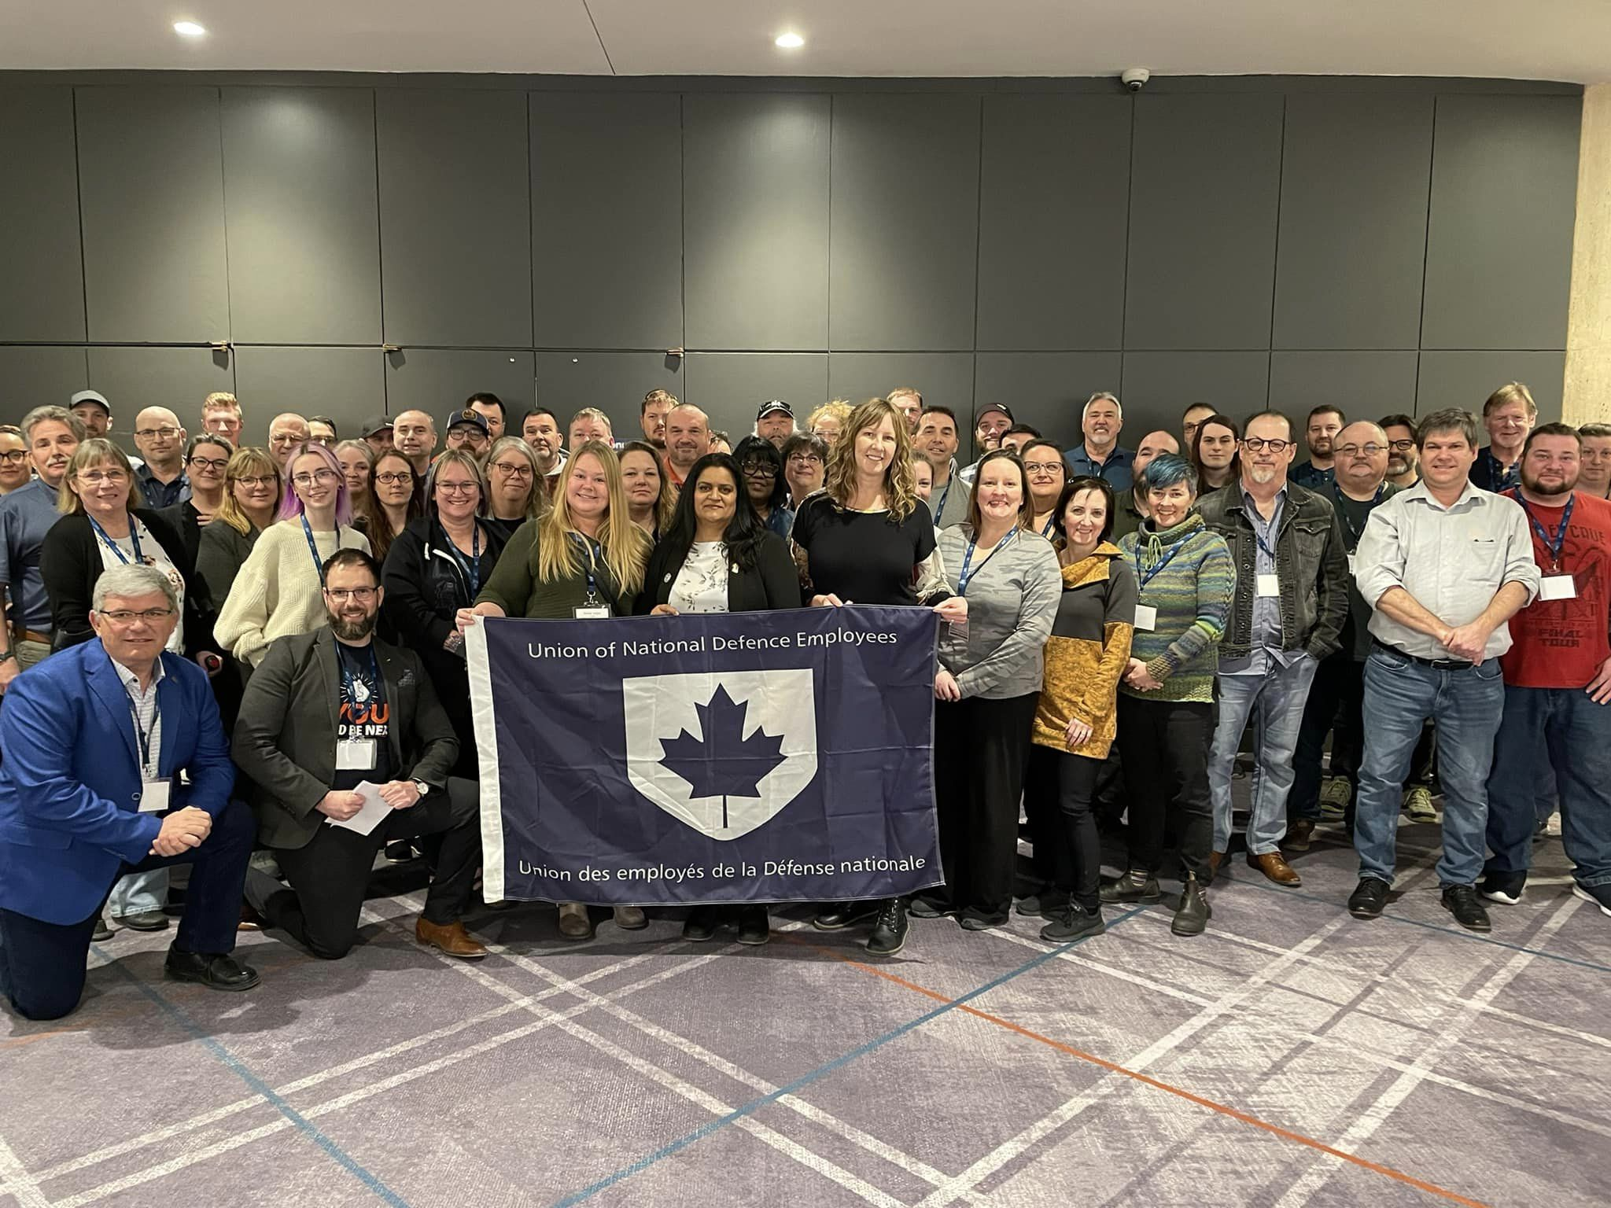

The 2023 UNDE National Health and Safety Conference was held in Québec City, Québec on March 10th and 11th.
UNDE National Health and Safety Conference Agenda
Friday, March 10 | Activity | Speaker/Guest/Other
0800 - 0845 | Registration | France Boucher and Mandy Forgét
0900 - 0915 | Welcome: Co-Chairs (15 min) | Gérald Grenon and James Potts
0915 - 0940 | Ice Breaker (25 min) | Gérald Grenon and James Potts
0940 - 1010 | UNDE NP (30 min) | June Winger
1010 - 1040 | Health and Safety Rights (30 min) | Gérald Grenon and James Potts
1040 - 1050 | Break (10 min) | ******************
1050 - 1200 | Good News Stories in Health and Safety (1 hr 10 min) | Open Discussion
1200 - 1330 | Lunch (1 hr 30 min) | ******************
1330 - 1345 | Activity 1 (15 min) | Gérald Grenon and James Potts
1345 - 1445 | Mental Health (60 min) | Geneviève Francoeur
1445 - 1455 | Break (10 min) | ******************
1455 - 1555 | Office of Disability Management (60 min) | Geneviève Francoeur
1555 - 1605 | Break (10 min) | ******************
1605 - 1625 | Activity 2 p.1 (20 min) | Gérald Grenon and James Potts
1625 - 1630 | Announcements (5 min) | Gérald Grenon and James Potts

Saturday, March 11 | Activity | Speaker/Guest/Other
0900 - 0915 | Activity 2 p.2 (15 min) | Gérald Grenon and James Potts
0915 - 0945 | PSAC NEVP (30 min) | Sharon DeSousa
0945 - 1030 | PSAC/JLP Key Role of OHS Activists (45 min) | Dominic Lavoie et Nancy McLean
1030 - 1040 | Break (10 min) | ******************
1040 - 1130 | PSAC/JLP Key Role of OHS Activists (50 min) | Dominic Lavoie et Nancy McLean
1130 - 1300 | Lunch (1 hr 30 min) | ******************
1300 - 1320 | Activity 3 (20 min) | Gérald Grenon and James Potts
1320 - 1420 | Decibel Alert (60 min) | Serge Beaulieu
1420 - 1430 | Break (10 min) | ******************
1430 - 1530 | Decibel Alert (60 min) | Serge Beaulieu
1530 - 1540 | Break (10 min) | ******************
1540 - 1615 | Decibel Alert (35 min) | Serge Beaulieu
1615 - 1630 | Wrap Up and Adjournment (15 min) | Gérald Grenon and James Potts

This conference provided an opportunity for UNDE Health and Safety activists from across all regions to gather and discuss issues and ideas. UNDE National President June Winger and PSAC National Executive Vice President Sharon DeSousa delivered addresses to the delegation. Larry Rousseau, 1st Executive Vice President of the Canadian Labour Council, recorded a video, as did former UNDE National President John MacLennan. Subject matter experts Geneviève Francoeur, Dominic Lavoie, Nancy McLean, and Serge Beaulieu delivered presentations and workshops on a variety of salient topics.

Respectfully submitted,
James Potts and Gérald Grenon

Return to Work Report
I, along with Gérald Grenon, became members of the Disability Management Consultation Committee (formerly the Return-to-Work Committee) and I have assumed the role of Co-Chair.
A meeting was held virtually on February 8th, 2023. This committee will meet two times per year though meetings will be more frequent until the committee is well-established.
At this meeting, we continued the discussion concerning the transition of Return-to-Work from D Safe G to the Office of Disability Management (ODM) under ADM(HR-Civ). It was mentioned that the ODM has requested a transfer of O&M funds to SWE in order to properly grow the program. This plan for expansion is ongoing.
There are a number of ODM offices already open and operating across the country with more to come. Some areas remain remotely serviced and all areas will have some for of service coverage by the end of this year. For areas with a physical office, in-person appointments are an option for particularly complex cases. Most ODM Case Managers come from a background in Health Services, be in physical or psychosocial health). They receive a robust training program as well as lunch-and-learn sessions; the most recent being on the topic of trauma-informed interactions with clients.
Work will continue to update the Occupational Fitness Assessment Form (OFAF) as it is dated and does not currently provide much of an opportunity to address mental health issues.
The next meeting will be scheduled for June to coincide with the next National Health and Safety Policy Committee meeting.

Respectfully submitted,
James Potts

