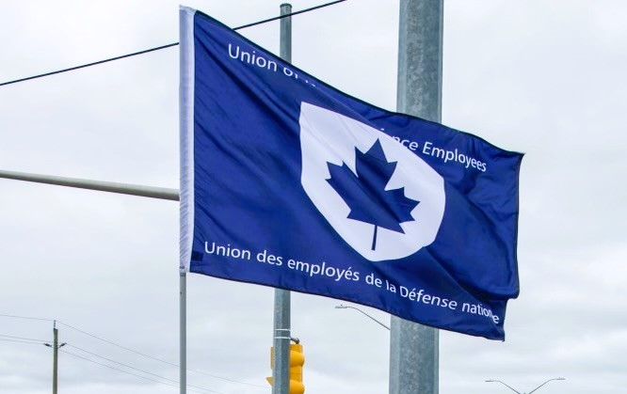

Ontario Region Report – April 19, 2023

The Ontario region is composed of 12 Locals:
00619, 00620, 00621 – Borden
00623 – London
00625, 00649 – Toronto
00629, 00639 - Petawawa
00635 – North Bay
00637, 00650 – Trenton
00641 – Kingston
~ 3,000 members in the region

VP Ontario: James Potts VP Ontario
DVP Ontario: Jayne Pollock
List of Activities since Nov 2022
- Nov 15 – Local 00625 AGM, Hybrid – VP attended virtually
- Nov 22 – Locals 00629 and 00639 AGMs, in person – VP attended
- Nov 28 – Local 00637 AGM, hybrid – VP attend in person
- Nov 29 – Local 00641 AGM, in person – VP attended in person
- Dec 1 – Local 00623, Hybrid – VP attended in-person with National President
- Dec 7 – Local 00649 AGM, hybrid – VP attended in person with EVP
- Dec 7 – Locals 00619, 00620, and 00621 AGMs, in person – VP attended with EVP
- Dec 8 – Local 00635 AGM, in person – VP attended with DVP and EVP
- Jan 9 – UNDE Young Workers meeting – Virtual
- Jan 10 – UNDE Ontario Zoom Meeting
- Jan 15-21 – PSAC Internal Investigator training in Calgary, Alberta
- Jan 24 – Workplace Harassment and Violence Prevention Meeting, Virtual
- Jan 25 – UNDE Standing Bylaw Committee Meeting, Virtual
- Jan 26-29 – PSAC National Health and Safety Conference in Montreal, Quebec
- Jan 31 – Attended Deputy MND Town Hall in Kingston, Ontario
- Feb 7 – PSAC Ontario Zoom Meeting
- Feb 8 – Disability Management Consultation Committee Meeting, Virtual
- Feb 9 – National Health and Safety Policy Committee Meeting, Virtual
- Feb 15 – UNDE Local 00641 GMM, in person
- Feb 22 – UNDE Standing Bylaw Committee meeting (all day) in Ottawa, Ontario
- Feb 23-26 – UNDE Local Presidents Conference in Ottawa, Ontario
- Mar 9-12 – UNDE National Health and Safety Conference in Québec City, Québec
- Mar 16-19 – UNDE Mobilization Summit in Toronto, Ontario
- Mar 29 - UNDE Standing Bylaw Committee Meeting, Virtual
- Apr 3 – UNDE Young Workers Meeting, Virtual
- Apr 12 – Emergency AGM: Borden Local 00619, in person – VP attended
- Apr 13 – Byelection in Trenton: Local 00650, in person – VP attended
- Apr 17 – UNDE Young Workers Meeting, Virtual

Virtual meetings for the Ontario region continue and have been very successful at connecting members from across the region. All Local Executives and Stewards are welcome to attend. These meetings provide an opportunity to connect and discuss issues and strategies across the region. Cohesion between Locals continues to increase across the region. There have been some hiccups, but I remain very positive about the future of not only the Region, but of UNDE as a whole.
I have participated in meetings of the Standing Bylaw Committee (SBC) (see SBC report), the RPOps Ontario LMCC (see RPOps Ontario report), the National Health and Safety Policy Committee (NHSPC) (see NHSPC report), the Young Workers Committee (see Young Workers report), Disability Management Consultation Committee (Co-Chair), and the Workplace Harassment and Violence Prevention Working Group.
I participated in the PSAC Internal Investigator training course in Calgary, Alberta, and am now on the roster of investigators who can participate in investigations in both official languages.
In April, I became the trustee for Local 00619 when the entire executive resigned. An election was quickly scheduled for the following week and all positions were successfully filled. I will continue to assist the new executive as they become more comfortable in their respective roles, as well as working together as a cohesive team.
ESA rollout and strike information:
I have been copied on ESA emails to members from the NCR, letters being delivered by civilian supervisors, emails being sent without informing a union rep, etc. For one of them, my email address was listed as vp.ont@forces.gc.ca and when that bounced back, they just used my actual forces address. Some managers have been encouraging striking employees to bring their laptops home so they can WFH. Having participated in the virtual training brief for supervisors and managers, I know exactly what direction has been given from HR(Civ) and it is evident that some has fallen on deaf ears.
Upcoming Activities
- Apr 21-23 – PSAC National Young Worker Conference
- Apr 26 – ADM(Fin) Youth Network Event UNDE panelist in Ottawa
- June 5-9 – Safety Program Development and Evaluation Technique (SPDET) Policy Review Working Group in Ottawa
- June 7 – National Health and Safety Policy Committee meeting in Ottawa - Hybrid
- June 8-12 – PSAC Ontario Regional Convention

Respectfully submitted,
James Potts

