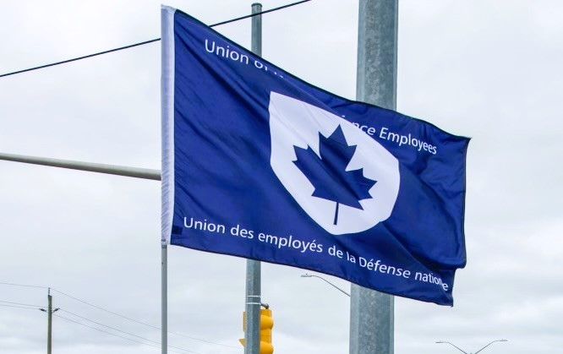

Ontario Regional Report February 2024

VP Ontario: James Potts
DVP Ontario: Chris Snooks

The Ontario region is composed of 12 Locals:
00619 Borden, President Neil Creech
00620 Borden, President Serge Desbiens
00621 Borden, President Jayne Pollock
00623 London, President Mandy Forgét
00625 Toronto, President Dan Barrett
00649 Toronto, President Kevin Hofer
00629 Petawawa, President Randy Phinney
00639 Petawawa, President Chandra Buschold
00635 North Bay, President Ken Bovair
00637 Trenton, President Cheryl Gough
00650 Trenton, President Tanisha Da Silva
00641 Kingston, President Tracy Astbury-Hart
~ 3,000 members in the region

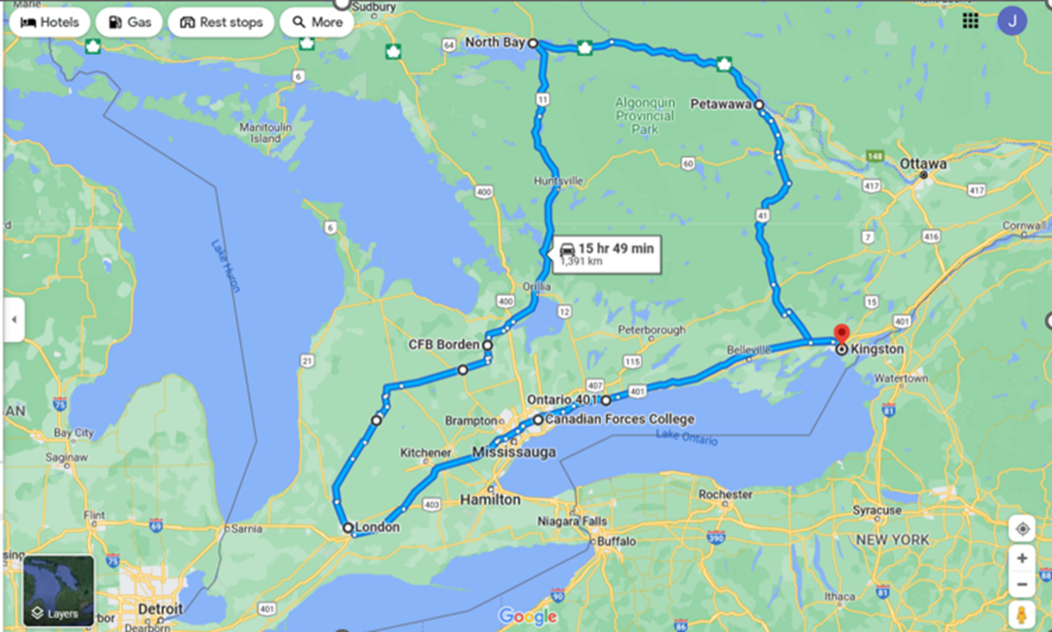

List of Activities Since the last NE Meeting
2023
- Sept 4 – Labour Day, Victoria Park, Kingston, ON
- Sept 5 – RMC LMCC
- Sept 18-22 – NE Meeting, Ottawa, ON
- Sept 25 – Investigation Meeting, Virtual
- Sept 27 – NHSPC Meeting, Virtual
- Oct 10 – Standing Bylaw Committee Meeting, Virtual
- Oct 12 – Investigation Meeting x 2, Virtual
- Oct 15-17 – Local 00623 Strike Discipline Meeting, London, ON
- Oct 25 – Investigation Meeting, Virtual
- Oct 27 – RPOU Ontario UMCC, Virtual
- Nov 1-2 – NBoD Meeting, Ottawa, ON
- Nov 7 – Investigation Meeting, Virtual
- Nov 15 – RCAF L2 UMCC, Virtual
- Nov 15 – Local 00641 AGM, Kingston, ON
- Nov 16 – Locals 00637 and 00650 AGMs, Trenton, ON
- Nov 17 – Local 00625 AGM, Toronto, ON
- Nov 19-24 – Ontario Federation of Labour Convention, Toronto, ON
- Nov 30-Dec 2 – Local 00623 AGM, London Ontario
- Dec 4 – GLMC ADM(Mat) UMCC, Virtual
- Dec 5 – NHSPC Meeting, Virtual
- Dec 5-6 – Locals 00619, 00620, 00621 AGMs, Borden, ON
- Dec 7 – Local 00635 AGM, North Bay, ON
- Dec 8-9 – Locals 00629 and 00639 AGMs, Petawawa, ON
- Dec 10-14 – PSAC Anti-Racism Representation Course, Ottawa, ON
- Dec 14 – RCAF L1 UMCC, Ottawa, ON
- Dec 15-17 – PSAC Leadership Conference, Ottawa, ON
2024
- Jan 3 – Labour College of Canada (LCC), Virtual
- Jan 8 – Zoom Meeting
- Jan 10 – Local 00641 Strike Discipline Meeting, Kingston, ON
- Jan 11 – NPF Briefing, Virtual
- Jan 15-19 – NPF Strike Picket, Kingston, ON
- Jan 17 – LCC, Virtual
- Jan 22 – NHSPC Terms of Reference Working Group, Virtual
- Jan 23 – CMSG UMCC, Virtual
- Jan 24 – LCC, Virtual
- Jan 25 – RPOU Ontario UMCC, Virtual
- Jan 31 – LCC, Virtual
- Feb 7 – LCC, Virtual
- Feb 13 – NHSPC Terms of Reference Working Group, Virtual
- Feb 13-14 – NPF Rally, Ottawa, ON
- Feb 22-24 – Local Presidents Conference, Ottawa, ON
- Feb 24 – March 2 – LCC, Harrison, BC

UNDE Portfolios:
UNDE Bylaws
Health and Safety
Return to Work
4th Canadian Division Support Group
Real Property Operations Unit (Ontario)
ADM (Mat) Group
Materiel Support Group
Royal Canadian Air Force (RCAF) L1 and RCAF L2

Strike discipline has been extremely challenging due to the widespread ability for telework. As such, Locals have been asking members who chose not to participate in picket lines to provide evidence that they did not get paid for performing struck work. Though this has certainly caused some tension, it is also the best way to respect all of the members who went without pay for the entire strike and supported picket lines. Some Locals have completed the entire process while others are in various stages of completion. I served as Chair of the strike discipline meeting for Local 00623 and will be doing the same for Locals 00637 and 00641 in March.
Real Property Operations Ontario (RPOU Ont) vacancies and contracting out continue to affect several Locals. The Unit claims to have insufficient Salary Wage Envelope (SWE) funding with which to fill vacancies. They do, however, have the Operations and Maintenance (O&M) funding, which can be used to hire contractors. This is a very serious issue as it results in the erosion of our membership and an overall decrease in the quality of work being performed. These issues have been raised to the ADM(IE) and ADM(Hr-Civ) levels and also have the attention of the UNDE National President.
Staffing issues continue to be a problem. Many of these concern nepotism, conflict of interest, ex-military hires, and external non-advertised processes. Some complaints have been filed formally while others are immune from recourse due to the limited scope of the job advertisement or the nature of the process itself. An end of year staffing freeze is affecting select units, such as the Royal Military College of Canada. This is either due to an overabundance of previous staffing actions by the L2: Canadian Defence Academy, or out of caution due to the ongoing Canadian Military Colleges review.
I have participated in meetings of the Standing Bylaw Committee (SBC) where I became the committee co-chair, the RPOU Ontario UMCC, the National Health and Safety Policy Committee (NHSPC), RCAF L1 and L2 UMCC, the ADM (Mat) Group and Materiel Support Group. I also participate as a member of the Workplace Harassment and Violence Prevention Working Group, the Working Group on the National Standard of Canada for Psychological Health and Safety in the Workplace, the NHSPC Terms of Reference Working Group, and the Safety Program Development and Evaluation Technique (SPDET) Working Group.

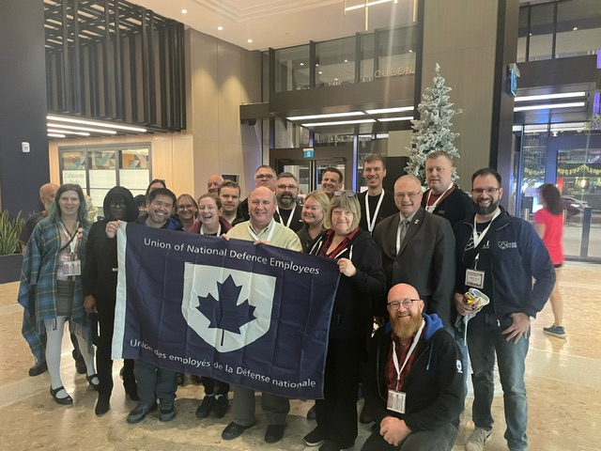
Photo: UNDE Delegation at the Ontario Federation of Labour Convention 2023.
At the end of 2023, I completed a very successful AGM Tour with National President June Winger. It was a great experience having the opportunity to visit each Local and speaking with members. I appreciate seeing more familiar faces each time I visit locals, but I also find it to be so encouraging that there are always newly engaged members as well.
Local 00639 in Petawawa has been facing hardship due to one of the employers, Toure Cleaning Services, not paying their employees and then abandoning their 2 contracts. Dexterra, holder of the 3rd contract, will be taking over pending a new tender. Our hope is that we can convince DND to contract this work back in to the Public Service and hire the 70 members who are currently out of work. President Winger has sent a letter to the Deputy Minister of National Defence that was co-authored by Elanor Sherlock. Conversations have taken place with the CO of RPOU Ontario, the OC of RPOU Petawawa, and the BComd of CFB Petawawa as well.
I was honoured to be chosen as the point of contact for French language media interviews regarding the ongoing Non-Public Funds strike. I gave interviews (recorded and live) with CBC/Radio-Canada. I continue to support NPF picket lines and rallies where possible.
UNDE Module 8: Grievance Procedures – Treasury Board was held in Barrie, Ontario earlier this month. A second session in Kingston, Ontario is panned for June 2024.
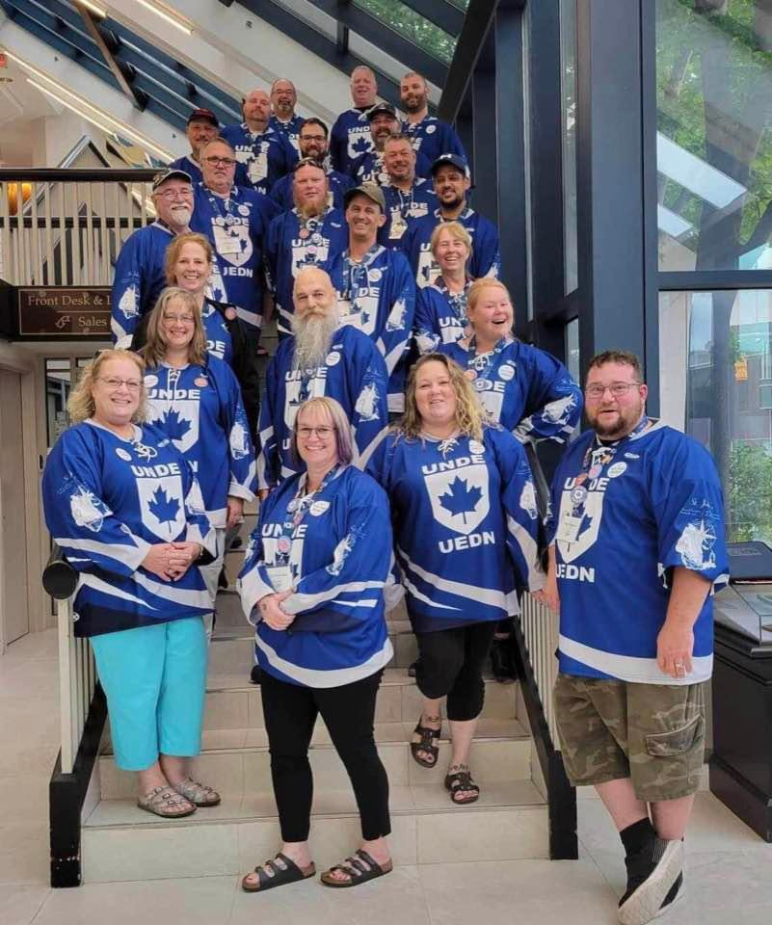
Photo: Ontario Delegation and Observers - UNDE Triennial Convention 2023, Saint-John’s, Newfoundland.
Planning is underway for an Ontario Regional Conference to be held in 2024 in London, Ontario.

Respectfully submitted,

James Potts
Vice-President Ontario Region, UNDE

