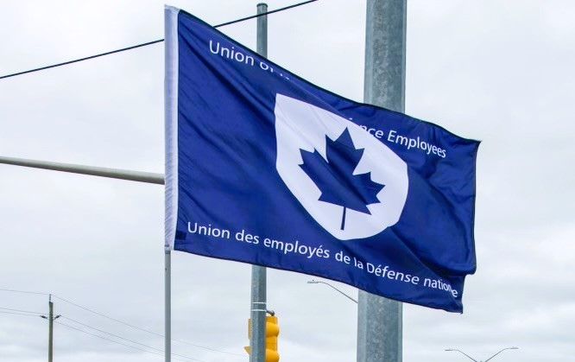
Ontario Regional Report May 2024
VP Ontario: James Potts
DVP Ontario: Chris Snooks

The Ontario region is composed of 12 Locals:
00619 Borden, President Neil Creech
00620 Borden, President Serge Desbiens
00621 Borden, President Jayne Pollock
00623 London, President Mandy Forgét
00625 Toronto, President Dan Barrett
00629 Petawawa, President Randy Phinney
00635 North Bay, President Ken Bovair
00637 Trenton, President Cheryl Gough
00639 Petawawa, President Chandra Buschold
00641 Kingston, President Tracy Astbury-Hart
00649 Toronto, President Kevin Hofer
00650 Trenton, President Tanisha Da Silva
~ 3,000 members in the region
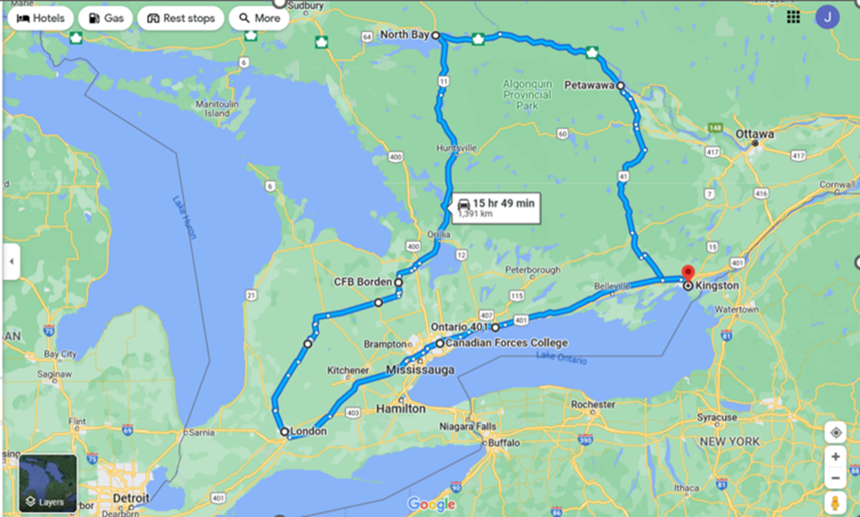

List of Activities Since the last NE Meeting
2024
- March 6 – Local 00641 Strike Discipline Meeting, Kingston, ON
- March 13 – RCAF L2 UMCC, Virtual
- March 19 – Terms of Reference Working Group (NHSPC), Virtual
- March 19 – Local 00637 Strike Discipline Meeting, Trenton, ON
- March 20-22 – National Health and Safety Policy Committee, Ottawa, ON
- March 21 – NPF Day of Action Rally, Ottawa, ON
- April 24 – Labour College of Canada meeting, Virtual
- May 10-12 – PSAC Health and Safety Policy Forum, Ottawa, ON
- May 15-16 – RCAF L1 UMCC, Ottawa, ON
- May 17 – ADM(IE) UMCC, Ottawa, ON
- May 21-24 – UNDE NE Meeting, Ottawa, ON
- May 25 – UNDE Caucus for PSAC National Triennial Convention, Ottawa, ON
- May 26-31 – PSAC National Triennial Convention, Ottawa, ON

UNDE Portfolios:
UNDE Bylaws
Health and Safety
Return to Work
4th Canadian Division Support Group
Real Property Operations Unit (Ontario)
ADM (Mat) Group
Materiel Support Group
Royal Canadian Air Force (RCAF) L1 and RCAF L2
Though not a lot of time has passed since the last National Executive meeting, it has remained a busy time in the Ontario region. The Non-Public Funds strike had a significant impact in the workplace for the affected locals. I continue to assist Ontario NFP Locals as required and where appropriate, including issues in regards to strike discipline.
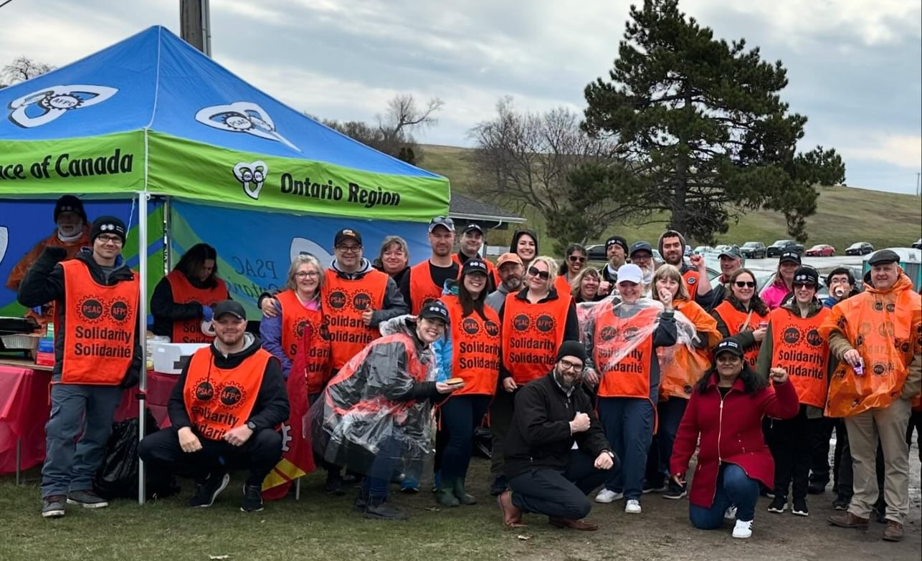
Photo: UNDE Local 00681 on the picket lines, April 10, 2024.
I attended a week-long in-person session of the Labour College of Canada at the end of February. For my Individual Learning Project, I have selected the issue of contracting out and the necessity of contracting back in. My specific focus for my research is the Town of Petawawa, Ontario, where members of Local 00639 have been facing extreme hardship as a result of a contractor abandoning his contract. Dexterra has taken over the contract but has yet to compensate the members for the work performed under Toure as per the agreement. Furthermore, Dexterra has laid off some members and has requested a voluntary reduction in hours from others to avoid more layoffs. This is a precarious situation but there is the potential for a positive outcome. The Deputy Minister of National Defence is reviewing the viability of contracting this work back in to the Public Service.
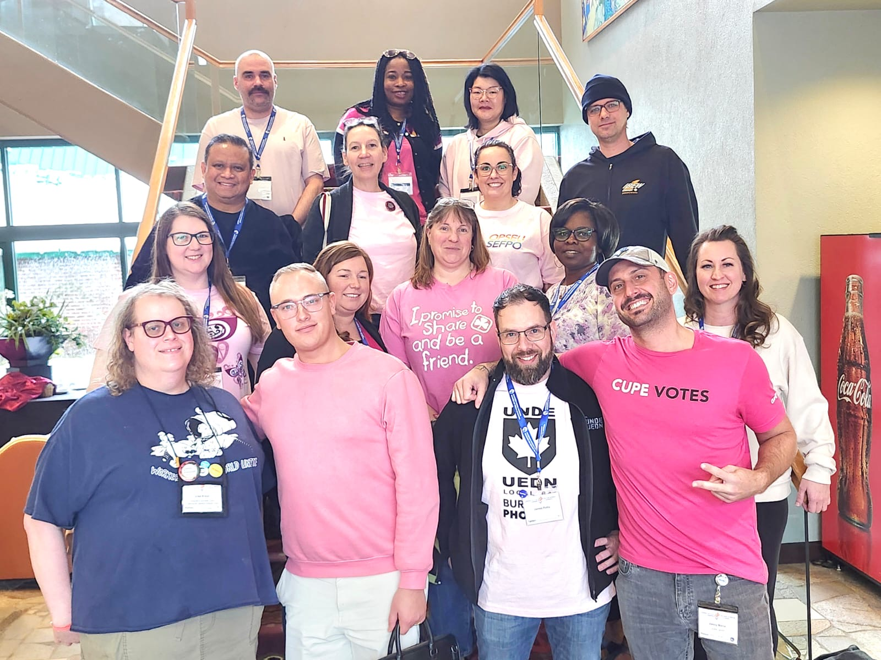
Photo: Labour College of Canada Cohort 12 in Harrison, BC, February 28, 2024.
Strike discipline has been extremely challenging due to the widespread ability for telework. As such, Locals have been asking members who chose not to participate in picket lines to provide evidence that they did not get paid for performing struck work. Though this has certainly caused some tension, it is also the best way to respect all of the members who went without pay for the entire strike and supported picket lines. Some Locals have completed the entire process while others are in various stages of completion. I served as Chair of the strike discipline meeting for Local 00637and 00641, and both were very successful meetings.
Real Property Operations Ontario (RPOU Ont) vacancies and contracting out continue to affect several Locals. The Unit claims to have insufficient Salary Wage Envelope (SWE) funding with which to fill vacancies. They do, however, have the Operations and Maintenance (O&M) funding, which can be used to hire contractors. This is a very serious issue as it results in the erosion of our membership and an overall decrease in the quality of work being performed. These issues have been raised to the ADM(IE) and ADM(Hr-Civ) levels and also have the attention of the UNDE National President. This is a persistent issue and not unique to this region.
Staffing issues continue to be problematic. Currently, the Royal Military College of Canada is under a hiring freeze. This includes term and acting assignments, creating serious gaps.
UNDE Module 8: Grievance Procedures – Treasury Board will be held in Kingston, Ontario, in June 2024.
Planning is underway for an Ontario Regional Conference to be potentially held in 2024 in London, Ontario.

Respectfully submitted,

James Potts
Vice-President Ontario Region, UNDE

