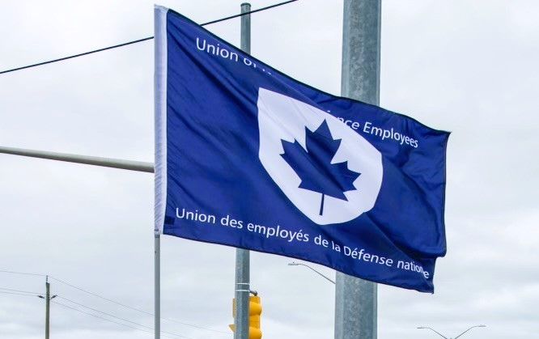
Ontario Regional Report May 1 – December 2, 2024
VP Ontario: James Potts
DVP Ontario: Chris Snooks

The Ontario region is composed of 12 Locals:
00619 Borden, President Neil Creech
00620 Borden, President Christopher Hamilton
00621 Borden, President Brian Duck
00623 London, President Mandy Forgét
00625 Toronto, President Dan Barrett
00629 Petawawa, President Randy Phinney
00635 North Bay, President Nathan Buisman
00637 Trenton, President Cheryl Gough
00639 Petawawa, President Chandra Buschold
00641 Kingston, President Chris Snooks
00649 Toronto, President Kevin Hofer
00650 Trenton, President Marc Sisson
~ 3,300 members in the region
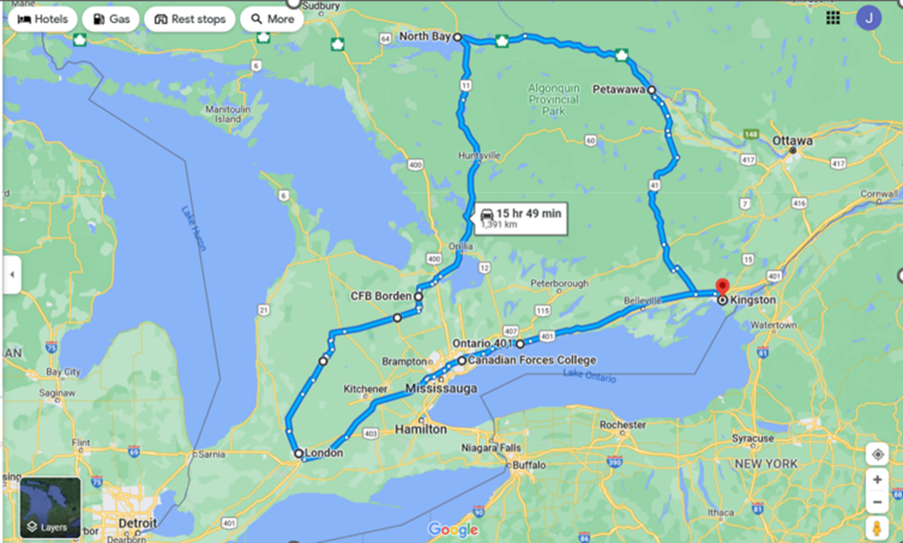

List of Activities Since the last NE Meeting
- May 10-12 – PSAC Health and Safety Policy Forum, Ottawa, ON
- May 15-16 – RCAF L1 UMCC, Ottawa, ON
- May 17 – ADM(IE) UMCC, Ottawa, ON
- May 21-24 – UNDE NE Meeting, Ottawa, ON
- May 25 – UNDE Caucus for PSAC National Triennial Convention, Ottawa, ON
- May 26-31 – PSAC National Triennial Convention, Ottawa, ON
- June 11 – RPOU Ontario UMCC meeting, Virtual
- June 12 – Labour College of Canada meeting, Virtual
- June 12 – ADM(Mat) UMCC meeting, Virtual
- July 3 – Labour College of Canada meeting, Virtual
- July 14-19 – Labour College of Canada, in-class, McMaster University, Hamilton, ON
- August 24-25 – Capital Pride, Ottawa, ON (personal)
- September 2 – Labour Day, Kingston, ON
- September 12-15 – Guest Speaker at the NLNB Regional Conference, Rocky Harbour, N.L.
- September 16 – NHSPC meeting, Virtual
- September 18 – Labour College of Canada meeting, Virtual
- September 19 – RPOU Ontario UMCC meeting, Virtual
- October 1 – Kingston Area Council meeting, Virtual
- October 2 – UNDE Ontario Region Zoom meeting, Virtual
- October 10 – Labour College of Canada meeting, Virtual
- October 22-24 – NHSPC meeting, Ottawa, ON
- October 27-31 – UNDE Ontario Fall School 2024, Markham, ON
- November 4 – Locals 629 + 639 AGMs, Petawawa, ON
- November 5 – Local 635 AGM, North Bay, ON
- November 6 – Locals 619, 620, 621 AGMs, Borden, ON
- November 13 – Local 649 AGM, Toronto, ON
- November 14 – Local 625 AGM, Toronto, ON
- November 20 – Local 641 AGM, Kingston, ON
- November 21 – Locals 637 + 650 AGMs, Trenton, ON
- December 3-4 – Local 623 AGM, London, ON
- December 5-8 – PSAC Ontario Anti-Harassment Summit, Toronto, ON
- December 7 – Vigil for The National Day of Remembrance and Action on Violence Against Women, Toronto, ON
- December 9-12 – National Executive meeting, Toronto, ON
- December 13-15 – UNDE Bargaining Conference, Toronto, ON
- December 17 – NHSPC meeting, Ottawa, ON

UNDE Portfolios:
UNDE Bylaws
Health and Safety
Return to Work
4th Canadian Division Support Group
Real Property Operations Unit (Ontario)
ADM (Mat) Group
Materiel Support Group
Royal Canadian Air Force (RCAF) L1 and RCAF L2

It has been a very busy time in the Ontario Region since the last National Executive meeting. Some major activities include the 2024 PSAC National Convention, the UNDE Ontario Fall School 2024, preparing for the UNDE Bargaining Conference, and the AGM Tour.
Highlight of Regional Issues:
Staffing issues continue to be problematic. This is due to a combination of factors such as a lack of Salary Wage Envelope (SWE) at the L2/3 levels, and the continued overuse of non-advertised processes.
The RPOU Ontario Self-Help policy expansion raises many concerns about contracting-out as well as health and safety. In general, contracting issues have been ongoing and all information is being sent to the UNDE Special Projects Officer.
Separate Employer members of Local 639 in Petawawa continue to fight to receive wages they had earned, but were never paid, when Toure Cleaning Services held the contract. The UNDE LRO and PSAC continue to fight the issue and the matter is now in the hands of an arbitrator.
Contracting out/contracting in continues to be a significant concern. Locals are forwarding information to the UNDE Special Projects Officer. The issues faced by members of Local 639 further highlight the downsides of contracting public service work to private companies.

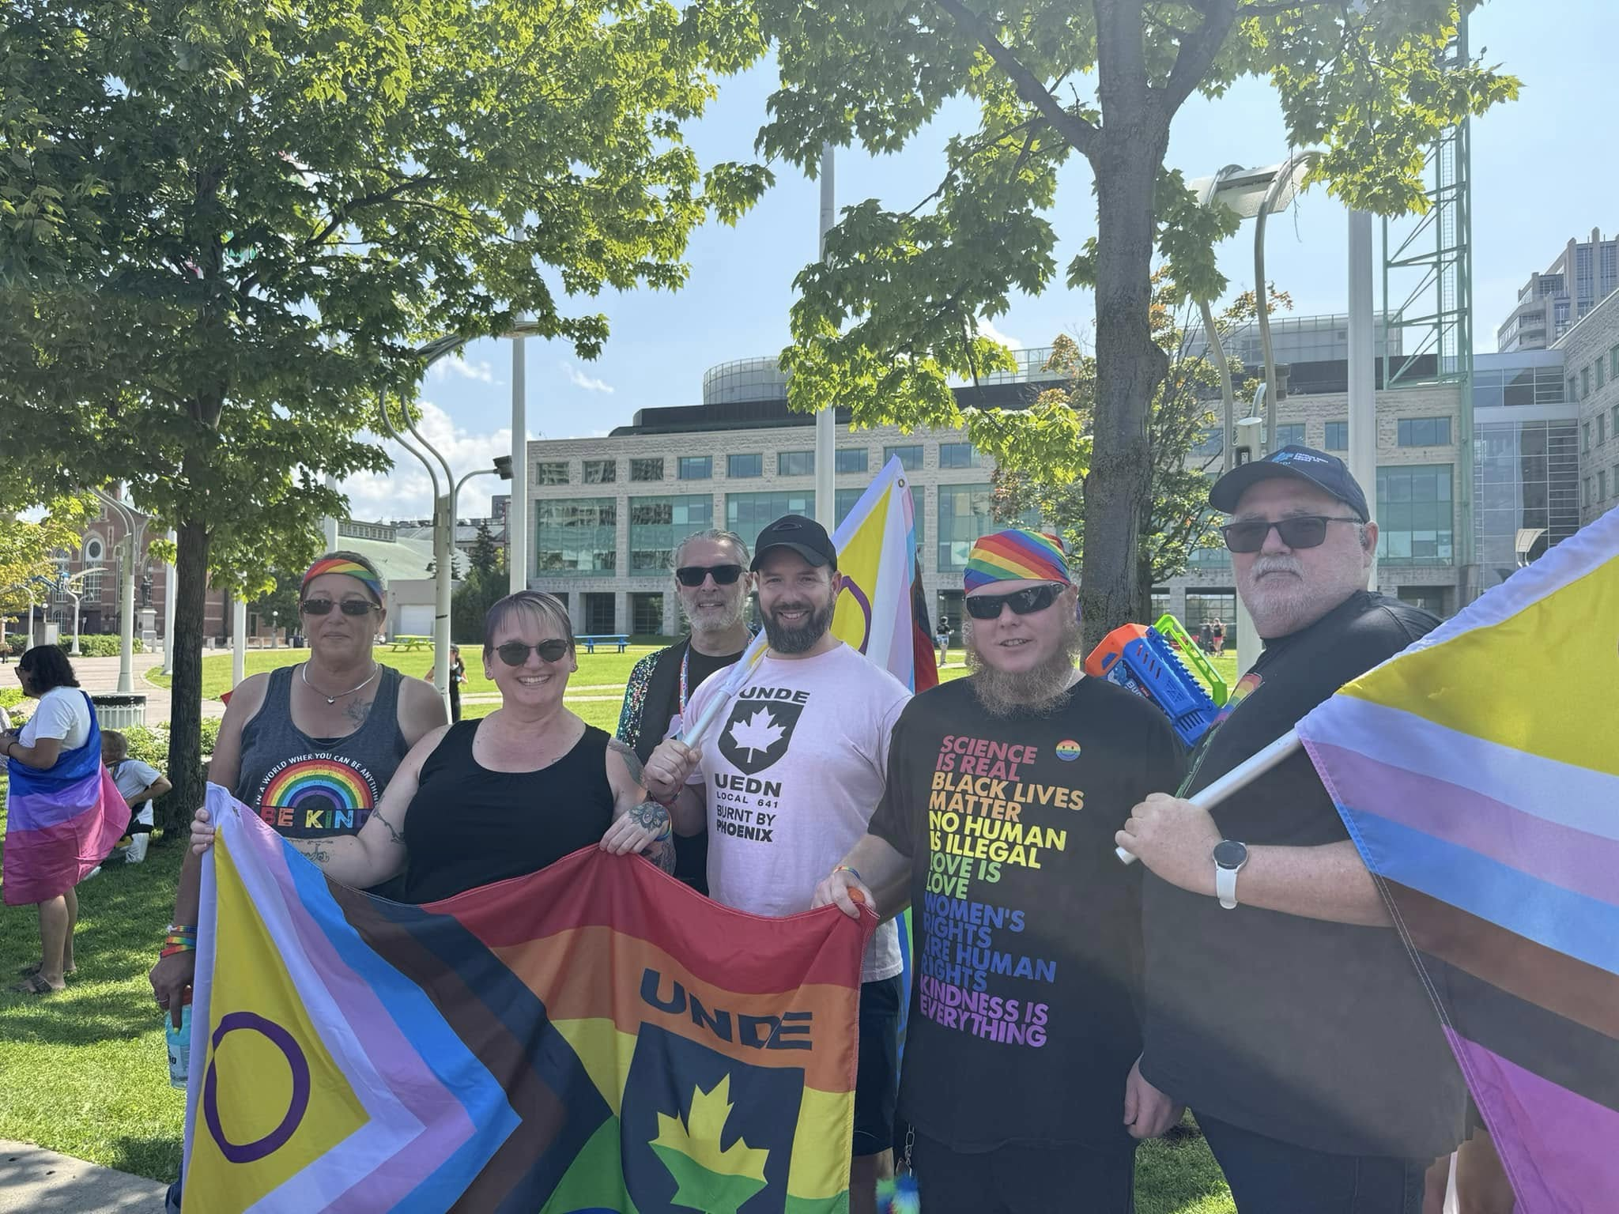
Photo: UNDE Ontario Members at Capital Pride 2024 in Ottawa, ON, August 25, 2024.
I was invited to be a guest speaker at the UNDE NLNB Regional Conference 2024. I prepared and delivered presentations on the Right to Refuse Dangerous Work, the Duty to Accommodate, the National Health and Safety Policy Committee and its sub-committees/working groups, and solicited for agenda items for the next UNDE National Health and Safety Conference to be held in 2025. I will be using these presentations to expand informal educational opportunities within the region.
The 2024 AGM tour wrapped up on December 4th. There are still many familiar faces within the UNDE Ontario Local Executive teams, as well as some new ones. Our goal is to ensure that all officers, new or old, have the tools with which to carry out their duties. New executive members and stewards will be given priority on any UNDE training that is offered in the region.

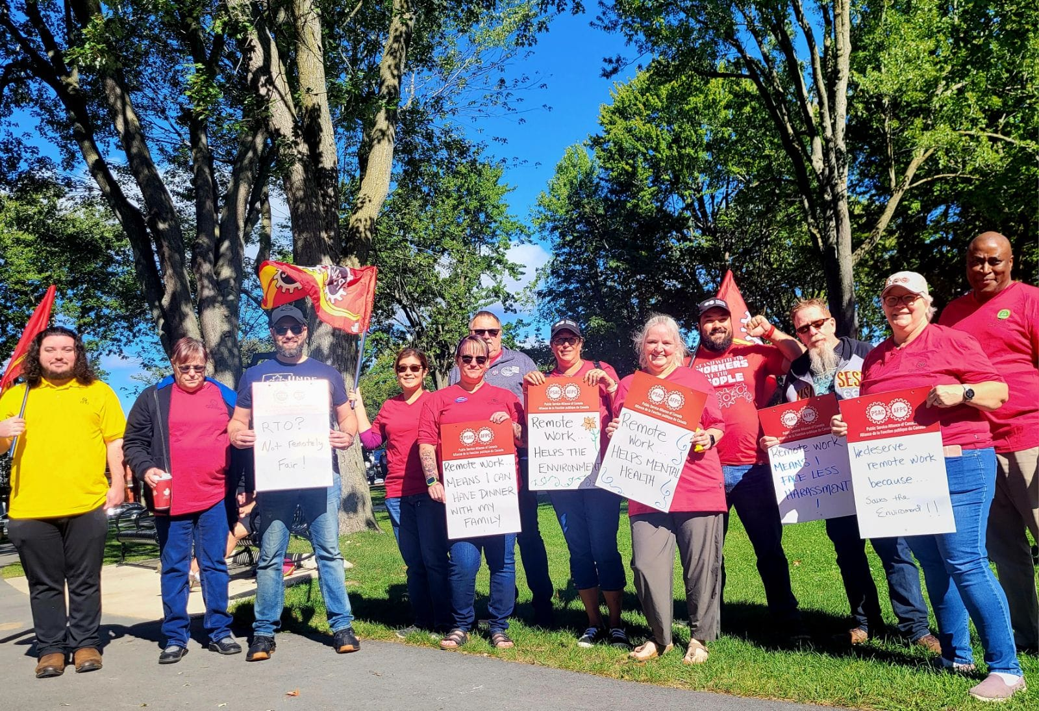
Photo: Labour Day 2024 in Kingston, ON, September 2, 2024.
Strike discipline has been completed for the Region (aside from 1 Local). This has been a difficult experience for some Locals and there will be many discussions on lessons learned and on how to proceed in the event of future strikes.
In October, we held the first ever UNDE Ontario Fall School in Markham, Ontario. Thirty-seven participants split between 2 groups undertook either Mod 9 or Mods 2, 3, 4 training while also engaging in networking on breaks and in the evenings. This event was so successful that holding UNDE Ontario Fall and Spring Schools will be the focal point of the 3-year education plan for the Region. Ad-hoc education will continue to be available for Locals where there is interest and a need.
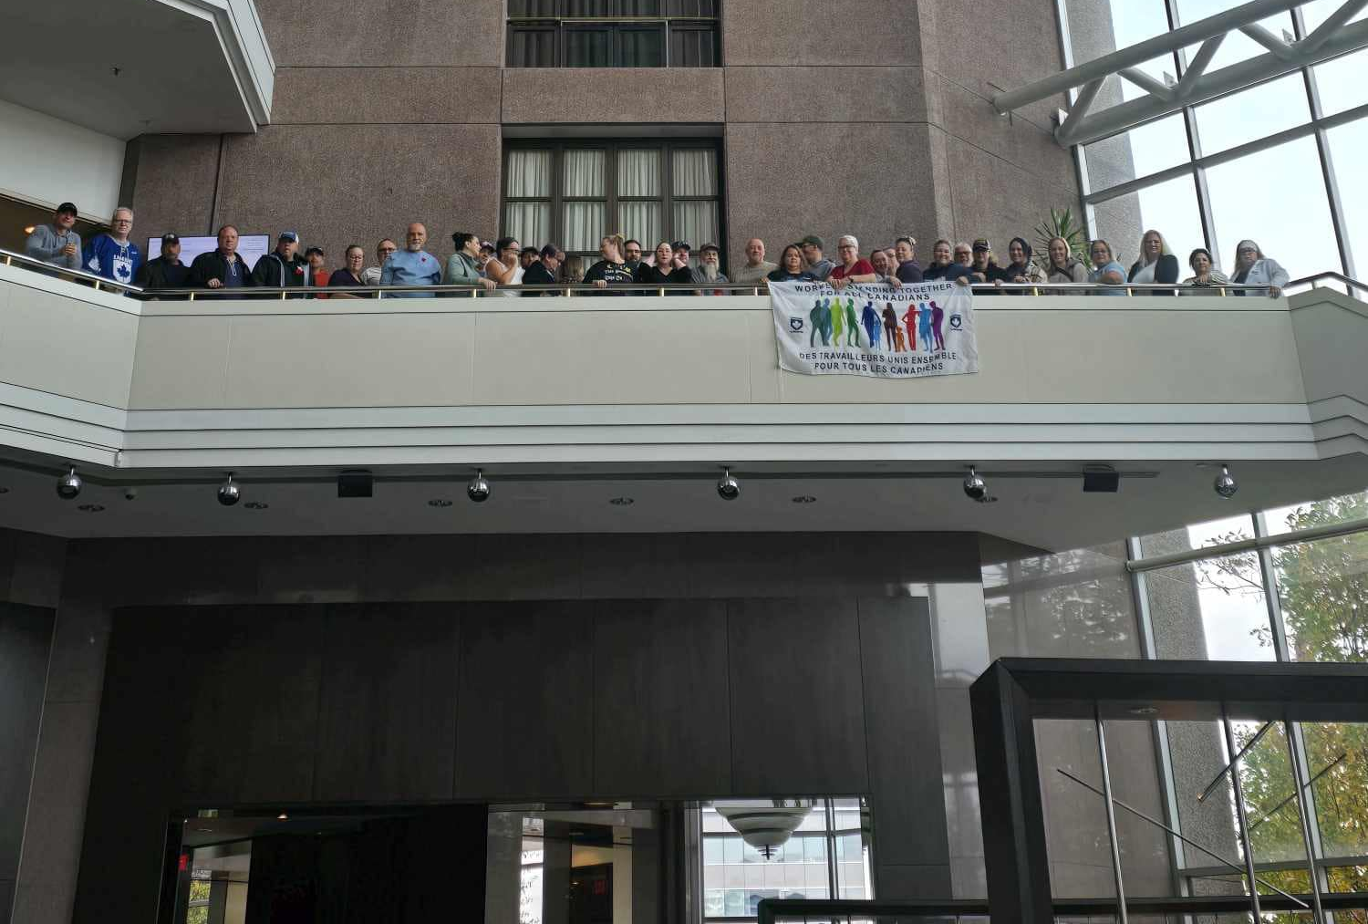
Photo: UNDE Ontario Fall School 2024 in Markham, ON, October 31, 2024.
By the reading of this report at the NE meeting, I will have participated in the PSAC Ontario Anti-Harassment Summit in Toronto, Ontario. The theme of this event was: Detoxifying our Workplaces, Union, and Communities. The goals of this summit include: building a common understanding of harassment; building confidence to move beyond bystander awareness towards actions that disrupt the systems that oppress; engaging with resources and content experts to hone and broaden your skills; and, collaborating with other PSAC Ontario activists to develop an Anti-Harassment Tool Kit.
I am currently entering the final phases of the Canadian Labour Congress’ Labour College of Canada, with graduation to take place at the end of February 2025. I have been learning about the history of labour unions while developing strategies for density-building and member engagement.
Respectfully submitted,
James Potts
Vice-President Ontario Region, UNDE

