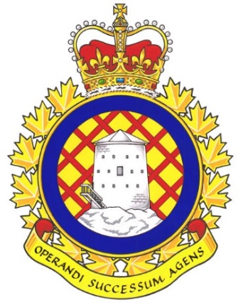

Real Property Operations Unit (RPOU) Ontario Report

There has been 1 UMCC meeting since the last NE meeting. It was held on April 15th, 2025.

UNDE members on this committee include:
Brian Duck, Local 00621 Borden
Dan Barrett, Local 00625 Toronto
Steven Yashinskie, Local 00629 Petawawa
Nate Buisman, Local 00635 North Bay
Cheryl Gough, Local 00637 Trenton
Chris Snooks, Local 00641 Kingston
James Potts, Co-Chair

Vacancy Management
Vacancy Reports continue to be provided at regular intervals without the need to make a request. These reports serve as the benchmark when making requests from other parts of the DND organization. It is a standing item and is produced by the committee secretary every few months. Staffing is expected to fill some vacant positions across the organization. The SWE allocation for this fiscal year is only slightly higher than it was last year (to account for pay increase tied to collective agreements. This does not allow for an increase in the size of the workforce. O&M has also been cut and it is very unlikely that RPOU will be able to more with less without there being a toll on the existing workforce. Current vacancy management reports list approximately 129 vacant positions within the organization.

Red Seal
Det Borden was in the process of hiring a Painter who does not possess an Interprovincial Red Seal. While they assured me that they did not have any plans to staff this position indeterminately with a candidate who did not have a trade certification, this is exactly what they intended to do. After assuring me that they would only place this member in a short acting (less than 4 months) position while he earned his Red Seal, a Notice of Consideration has seen been released showing an acting period of 1 year. I informed the OC and CO that there is an apprenticeship program available if that is their intent but they are not to reduce the requirements of a red Seal Trade position. The member has since been hired on the condition that he earn his Red Seal within 1 year. There is also an advertised process, though a Red Seal is listed as an “asset” and not an “essential” qualification. The CO of RPOU(O) has agreed that the Red Seal will remain the standard and that individuals who possess a Red Seal will be hired before anyone who does dot hold that qualification.
RPOU(O) will be exploring the viability of increasing their use of the apprenticeship program.
Self-Help
Contracting out is always a chief concern. RPOU Ontario has implemented their “self-help” policy, which has caused much concern. Essentially, Units are now in a position to use their own funding to contract out infrastructure work that RPOU would normally carry out. It also grants users the permission to conduct their own infrastructure work if the local RPOU detachment signs off on the plan. In a meeting with the OC of RPOU Det Petawawa, UNDE expressed their concerns and warned that this policy will likely result in the demise of RPOU as an organization.
An update was provided regarding the approximate number of requests and the nature of those requests. Painting and landscaping have been the most common, although instances remain low. Overall, no issues have been reported, though it has become clear that most detachments require more painters as there is a definite demand for painting work.
Standby/Callback
UNDE Local 641 President Kingston said some of his members raised concerns about changes in standby. Due to SWE pressures, the use of Standby is now very closely monitored. The worry is that there will now be gaps where no one is available to respond in the event of an emergency. Local 00621 reported that a window was broken during the recent ice storm and no one was on Standby, nor was anyone available for callback. As such, there is now water damage to the affected space. Photos have been requested.
Water Quality and Legionella Testing
Water tests are conducted throughout the year. In most instances, municipal water is being used and is tested by the municipality up to the point where it enters Base/Wing lines. The issues generally arise from old pipes in DND’s aging infrastructure. Testing results where lead or other hazardous materials have been detected will be shared with UMCC members.
Legionella testing has begun and will be rolled out nationally as a part of an annual initiative. This stemmed from an incident in Kingston, Ontario, where a member contracted Legionnaire’s Disease after working in an area with standing water in the basement of a DND building.

The next meeting of the RPOU Ontario UMCC is scheduled for June 2025.

Respectfully submitted,
James Potts

