

Chief Military Personnel (CMP) / Military Personnel Command (MILPERSCOM)
Programs under this L1:
Education & Training
Health Services
Casualty Support
Alternate Dispute Resolution
Canadian Armed Forces Transition Services
Recovery, Rehabilitation and Reintegration
Dependent Education
Member Assistance Program
Operational Trauma Stress Support Centres
Programs for Ill, Injured and Deceased
Chaplain General
Honours & Recognition
History & Heritage

Military Personnel Command’s mission is to “recruit, train and educate, prepare, support, honour and recognize military personnel and their families for service to Canada.”
There are 2 main councils which have been created in order to provide strategic support to MILPERSCOM senior leaders. The CF Personnel Management Council serves as the senior advisory forum established to assist the Chief Military Personnel in the exercise of her functional authority. This council meets quarterly. The Military Personnel Command Council serves as the L2 advisory committee, and meets semi-annually.

The CMP UMCC is finally being held on April 28th, 2025, after not having taken place since November 2023.
Management Co-Chair LGen Lise Bourgon and Labour Co-Chair Mr. Shawn King.

Canadian Military Colleges Review Board (CMCRB)

As a result of the Arbour Report, a review board was established to analyze the viability of Canadian Military Colleges. The full report can be found here: https://www.canada.ca/en/department-national-defence/corporate/reports-publications/report-cmcrb.html

Of the 49 recommendations, #46 is the most concerning for UNDE. It calls for a Facilities Management Contract to be established at the Royal Military College, Kingston, similar to Corpo St-Jean at CMR St Jean. This would impact over 100 civilian positions. Luckily, there appears to be little appetite to entertain this recommendation as the costs would far exceed current levels. This is due to the nature of Corpo St-Jean.

As we are currently in a federal election, it is not expected that we will know which recommendations will be accepted by the Minister of National Defence. Shockingly, the Canadian Defence Academy (CDA) has contracted professional consultation services (1 at RMC and 1 at CMR) to begin working on an implementation plan. With no clear decision on which recommendations will be accepted, it feels as though the CDA has put the cart before the horse in a seriously irresponsible way, given that each contract is costing nearly $24,000 for a month and the contractors believe they will be working for a 3-month period. Even more egregious is that the consultant for RMC is said to not meet the essential criteria set out in the tender, but CDA directed the vetting panel to select him anyway. Due to the signing of a confidentiality agreement, the individual who has raised this concern is unable to provide official documents or emails back up the claim.
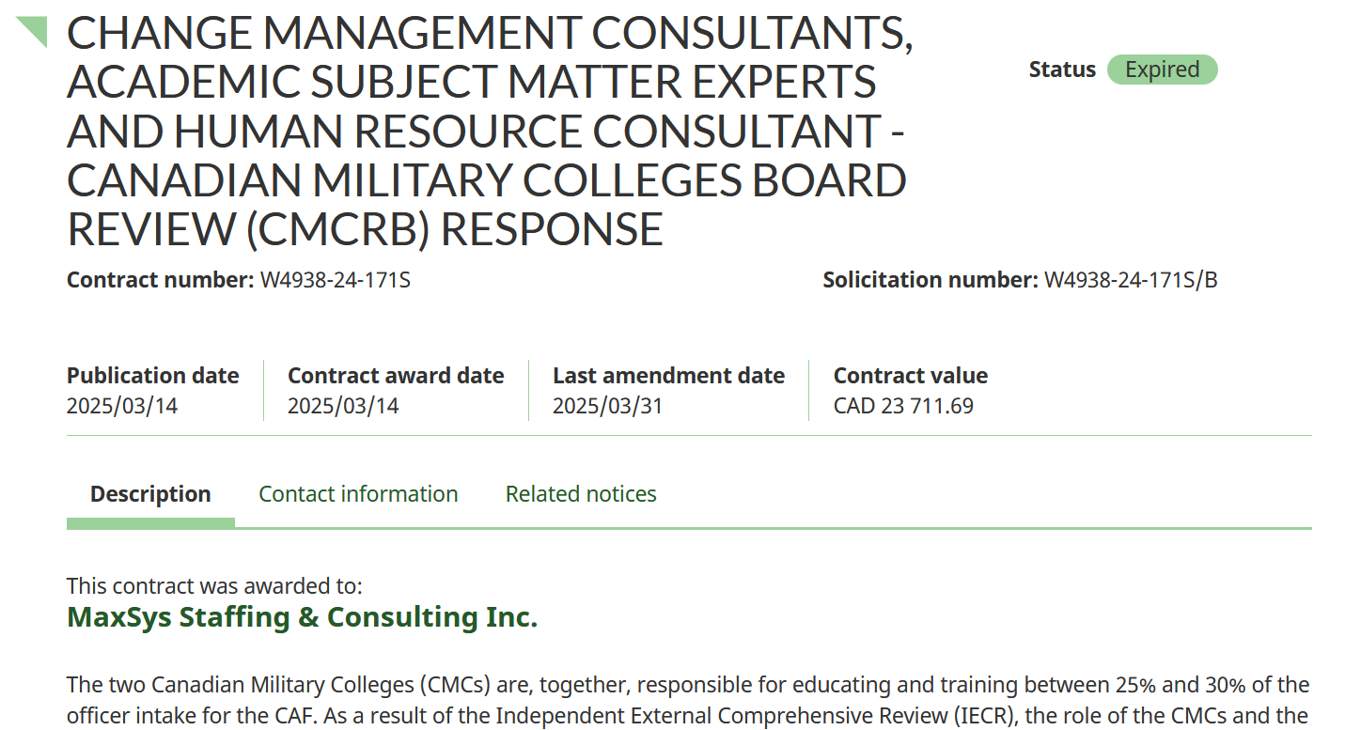

FOR FRENCH VERSION

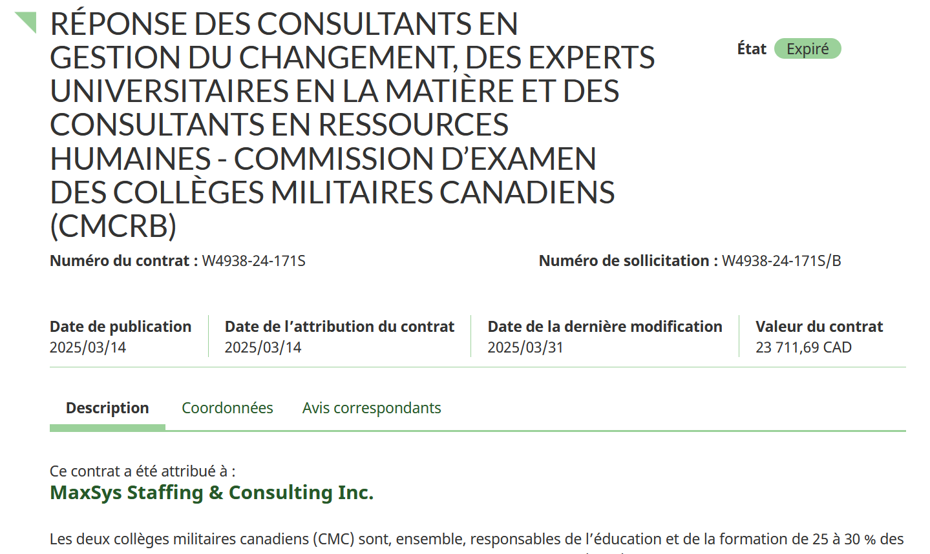

We must be prepared for the possibility that some of the proposed changes will be in conflict with UNDE’s core values. There must not be any concessions made with regards to the contracting out of unionized work.

Given that the first UMCC in almost a year and a half will be taking place after the deadline for this report, but prior to the National Executive meeting, a verbal update will be given on anything not captured in this report. We will be seeking some visibility on the business of both councils, as well as any other committee work that would affect UNDE members.

Respectfully submitted,

Shawn King and James Potts

