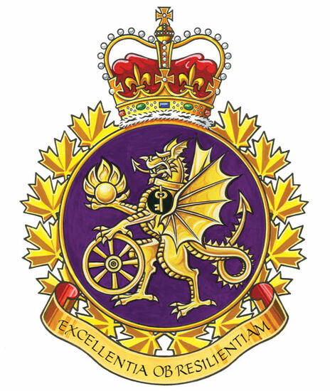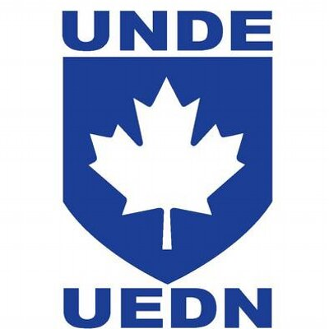

ADM (Mat) Group Report

The ADM (Mat) UMCC was held on June 12th, 2024.
Management Co-Chair Ms. Nancy Tremblay and Labour Co-Chair Mr. Adam Gray.

The President of UNDE Local 70602 raised a concern in December 2024 about parking at the National Printing Bureau Building in Gatineau, QC. He also wrote a letter to the Director General for Real Property at Public Works and Procurement Canada, which was very well received.
Total on-site occupancy is approximately1000 staff from several government departments. There are over 700 DND staff in this building of which 160 are UNDE members. DND is the major tenant at this location and has been there for over 40 years. The subject building is owned by PSPC and managed under contract by BGIS (a facilities management services company). The letter (added to meeting resources) summarizes the principal issues involved. UNDE involvement is to assist local and divisional management in supporting staff work life quality. The availability of parking at this site has caused and continues to cause significant stress for all staff.
The topic was discussed at the January UMCC. The meeting was fruitful and management was prepared to speak on the matter. They stated that this issue is too serious to wait for the next meeting to discuss it. As such, they will be providing an update at the next meeting (June 2025) but will also provide updates secretarially.
Some solutions currently in progress include:
- Adding 20-25 more spaces immediately with an ask for more to be created where there is currently grass
- Monthly passes for NPB staff as a priority
- Exploring the possibility of parking in the 555 Boul de la Carrière unused parking lot
- Providing a shuttle from the Casino area parking and making arrangements for NPB staff to park there
- We continue to work with local and divisional management on improving the local parking situation. How they're going to accommodate up to 150 more staff at NPB, with the eventual move of staff from 975 St. Joseph blvd in Gatineau, remains to be seen.

  - Official Language Profiles

The new directive concerning required language profiles for supervisors and managers working within a designated bilingual region has been causing some concern within the ADM(Mat) Group. The revised policy stipulates a requirement for a minimum of C/B/C second language testing results for those in supervisory positions. This will not impact incumbents but will impact all future staffing actions.

Respectfully submitted,
James Potts

