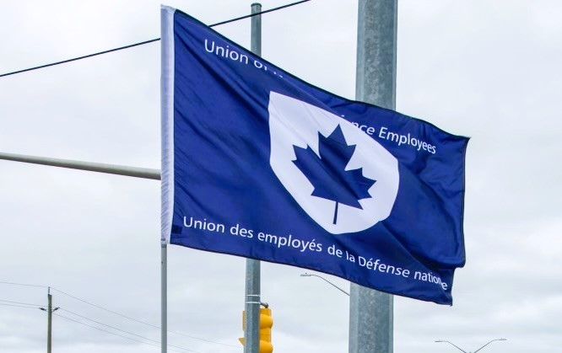
Ontario Regional Report December 1, 2024 – April 27, 2025
VP Ontario: James Potts
DVP Ontario: Chris Snooks
Human Rights Coordinator: Mandy Forgét
Young Worker: Tiffany George
The Ontario region is comprised of approximately 3,300 members across 12 Locals:
00619 Borden, President Neil Creech
00620 Borden, President Christopher Hamilton
00621 Borden, President Brian Duck
00623 London, President Mandy Forgét
00625 Toronto, President Dan Barrett
00629 Petawawa, President Steve Yashinskie
00635 North Bay, President Nathan Buisman
00637 Trenton, President Cheryl Gough
00639 Petawawa, President Chandra Buschold
00641 Kingston, President Chris Snooks
00649 Toronto, President Kevin Hofer
00650 Trenton, President Marc Sisson
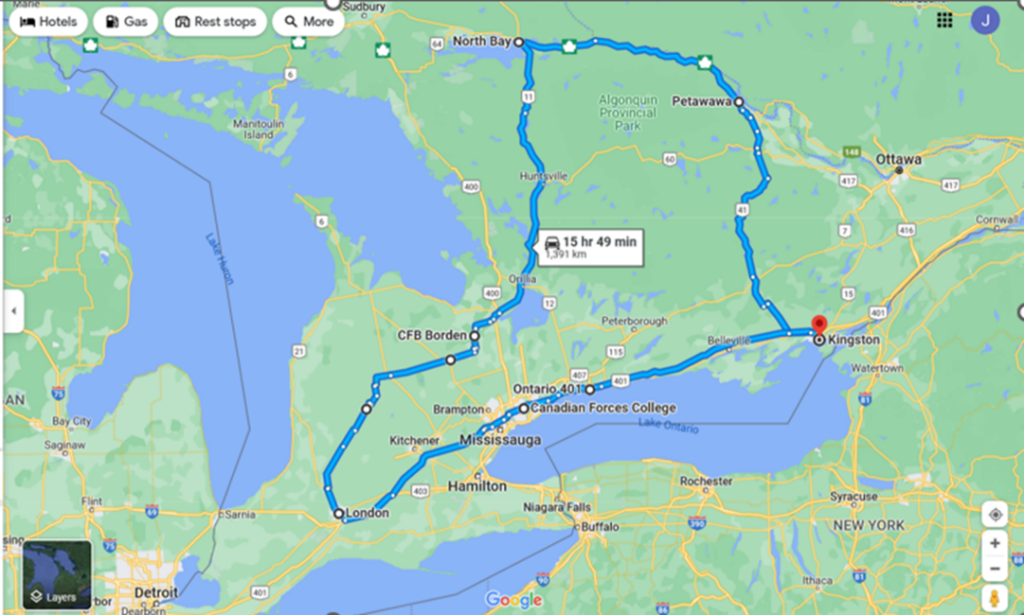
List of Activities Since the last NE Meeting
- December 3-4 – Local 623 AGM, London, ON
- December 5-8 – PSAC Ontario Anti-Harassment Summit, Toronto, ON
- December 7 – Vigil for The National Day of Remembrance and Action on Violence Against Women, Toronto, ON
- December 9-12 – National Executive meeting, Toronto, ON
- December 13-15 – UNDE Bargaining Conference, Toronto, ON
- December 17 – NHSPC meeting, Ottawa, ON
- January 8, 2025 – Labour College of Canada, virtual
- January 14 – GLMC, virtual
- January 15 – RCAF L2 UMCC, virtual
- January 16 – RPOU Ontario UMCC, virtual
- February 3 – Silica Teams Meeting, virtual
- February 4-5 – RCAF L1 UMCC, Ottawa, ON
- February 18-22 – PSAC Bargaining Conference, Montreal, QC
- February 22 - March 1 – Labour College of Canada Course and Graduation, Harrison, BC
- March 5 – CMP UMCC, Ottawa, ON (cancelled)
- March 6 – NHSPC, Ottawa ON
- March 6 – Silica Meeting (St-Jean), Ottawa, ON
- March 26 – RMC LMCC
- March 27-30 – UNDE LPC
- April 3-6 – PSAC Ontario Health and Safety Conference, Hamilton, ON
- April 15 – RPOU Ontario UMCC, virtual
- April 16 – UNDE Standing Bylaws Committee Meeting, virtual
- April 25 – Canadian Defence Academy (CDA) UMCC, Kingston, ON
- April 28 – Military Personnel Command (MPC) UMCC, Ottawa, ON
- April 29-May 1 – UNDE NE Meeting, Ottawa, ON
UNDE Portfolios:
UNDE Standing Bylaws
Health and Safety
Return to Work
4th Canadian Division Support Group
Real Property Operations Unit (Ontario)
ADM (Mat) Group
Materiel Support Group
Royal Canadian Air Force (RCAF) L1 and RCAF L2
CMP/MILPERSCOM

Regional Highlights:
It has been yet another busy time in the region (as highlighted above). Since the last reporting period, UNDE Ontario members have been involved in a number of events. UNDE and PSAC bargaining conferences offered members a chance at first-hand experience in the process of choosing demands and team members. Members also had the opportunity to participate in Anti-Harassment and Health and Safety events with PSAC Ontario. Locals continue to work on their plans for member engagement, with many events being planned for the impending warmer days.
On December 7th, UNDE Ontario members who were attending the Anti-Harassment Summit, braved the bitter cold to attend a candlelight vigil for The National Day of Remembrance and Action on Violence Against Women. It was a powerful and well-attended event.
Treasury Board Strike discipline for the region has finally wrapped up and all reports have been finalized. This has been most welcomed news to affected Locals.
President of Local 00623, and Regional Human Rights Coordinator, Mandy Forgét, has been appointed to the PA Group bargaining team. She will be an invaluable asset to the team and UNDE members can feel very confident with her at the table. Mandy was also presented with her 15-year pin in December.

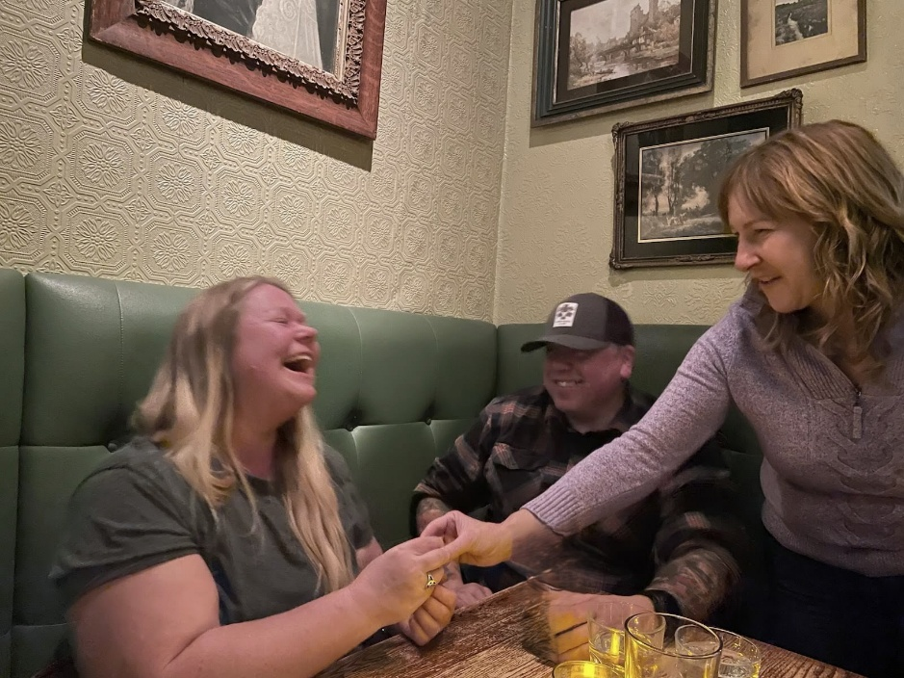

Photo: Local 00623 President, and Regional Human Rights Coordinator, Mandy Forgét, being presented with her 15-year pin by National President June Winger, December 2024.

PSAC Ontario held its first Anti-Harassment Summit and there were several UNDE members who participated. The goal of this summit is to create a toolkit for members with which to address harassment.
I graduated from the Canadian Labour Congress’ Labour College of Canada 14-month Diploma Program in February 2025. I encourage anyone interested in furthering their labour education to learn more about the program and the application process here: https://canadianlabour.ca/who-we-are/labour-education/labour-college-of-canada/
9 UNDE Ontario members from 2 separate employer Locals attended Mod 7 training in Ottawa, Ontario, along with members from the NPF and NLNB Regions. Feedback has been very positive and I was very pleased that we could offer this training as it had been several years since this course was run in Ontario.
5 UNDE Ontario members attended the 2025 PSAC Ontario Health and Safety Conference in Hamilton, Ontario. Topics included the effect of climate change on workplace health and safety, health and safety for migrant workers, the Workplace Safety Insurance Board (WSIB), and resolution writing for the 2025 PSAC National Health and Safety Conference.
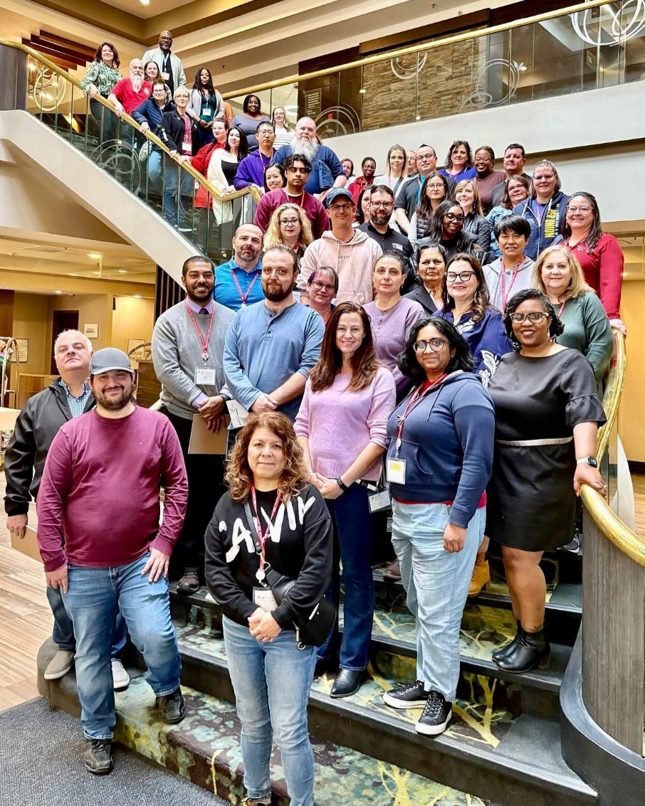
Photo: PSAC Ontario Health and Safety Conference 2025, Hamilton, ON, April 4-6, 2025.

10 out of 12 Ontario Locals have registered a Young Worker for the upcoming 2025 Young Worker Conference. This will be a fantastic opportunity to grow the movement and to create a more robust network of UNDE Young Workers. UNDE Ontario Regional Young Worker Representative, Tiffany George, has created a regional chat group and continues to expand the Ontario network.
Planning is currently underway for a UNDE Ontario Spring School 2025. Assuming there is enough interest and available funding for education, this event is expected to take place in June.

Additional Regional Initiatives
Staffing Issues tracker
Local Portfolios Database
Participation and Retention Tracker
Education (Fall/Spring Schools)
The UNDE Ontario Regional Conference will be held on September 5-6, 2025, at the Deerhurst Resort in Muskoka, Ontario.

Respectfully submitted,

James Potts
Vice-President Ontario Region, UNDE

