

BC RP Ops Report
December 2025
Our last Regional UMCC was held November 12, 2025, it was a good meeting with good discussion and news.
One of the top topics is how they will spend the new money that has been allocated to them, over and over we keep hearing DCC, Facility Management Contract and any other ways to spend money including CorCan.
We also were provided a briefing on Real Property Porfilio that comes with Coast Guard.
Approx 8,000 Canadian Coast Guard and DFO personnel were transferred to DND on Sept 2, 2025
DFO Real Property managed CCG RP Sites
- RP folks were DFO employees – 149 positions transferred to DND. Only 15 are in NCR.
- 500 sites and RP assets were also under DFO

Power Point Presentation is in the reference material folder that our CO shared with us.

RP Ops Pacific SWE Increase for the next 5 years
- 24/25- $22,612,995
- 25/26 - $24,789,920 (1.27% over allocation) (+$2M over last FY)
- 26/27 - $25,493,896 (+$703k)
- 27/28 - $27,680,259 (+$2.1M)
- 28/29 - $29,419,318 (+$1.7M)
RP Ops Pacific will see a growth of 155 new FTEs over the next 5-6 years. We currently have 302 positions filled, 92 vacancies for a total of 394 positions.
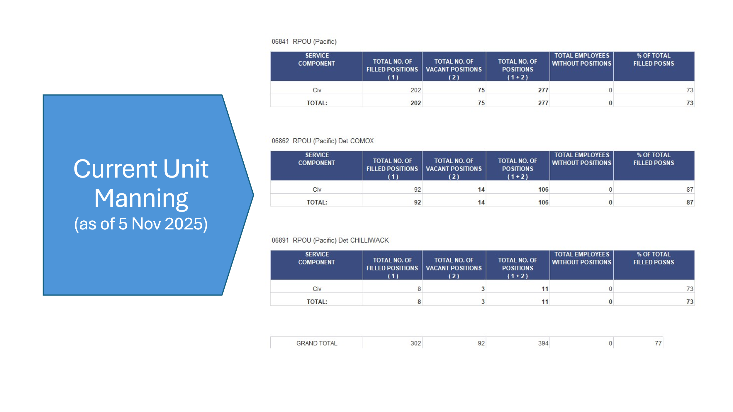

Staffing actions (from 1 Apr 2025 to 5 November 2025):
- Human resources staffing actions (not including under-4-month acting, casuals or students): 63
- Additionally approved staffing file: 43
- Total staffing file of previous FY: 92

SWE update:
- Current allocation: $24,789,920
- Current forecast: 1.27% over allocation ($305K)

Breakdown by type of staffing action and Sect/Det can be found in the reference material folder.
2025 Nov - Staffing Data.pptx
Attrition from 1 April - 5 November 2025
  - Retired / resigned: 17 RHQ: 1
  - ESQ: 8
  - CMX: 7
  - CWK: 1

  - Potential retirement by 31 March 26: 2
  - Retiring next FY: 3
  - Past retirement data from HR-Civ

Respectfully Submitted by
RVP BC
Marcelo Lazaro

