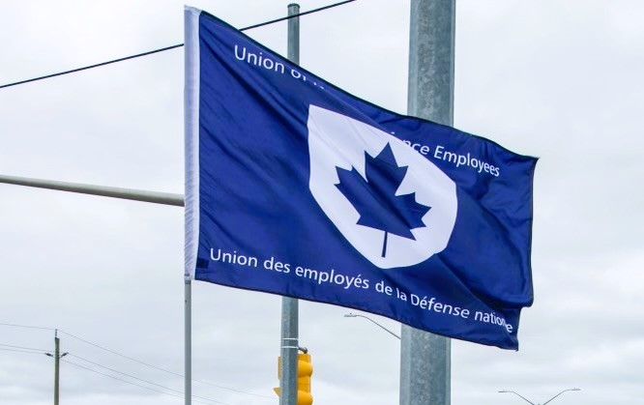
Ontario Regional Report December 1, 2024 – April 27, 2025
VP Ontario: James Potts
DVP Ontario: Chris Snooks
Human Rights Coordinator: Mandy Forgét
Young Worker: Tiffany George
The Ontario region is comprised of approximately 3,500 members across 12 Locals:
00619 Borden, President Neil Creech
00620 Borden, President Christopher Hamilton
00621 Borden, President Brian Duck
00623 London, President Mandy Forgét
00625 Toronto, President Dan Barrett
00629 Petawawa, President Jason Jones
00635 North Bay, President Nathan Buisman
00637 Trenton, President Cheryl Gough
00639 Petawawa, President Chandra Buschold
00641 Kingston, President Chris Snooks
00649 Toronto, President Kevin Hofer
00650 Trenton, President Marc Sisson
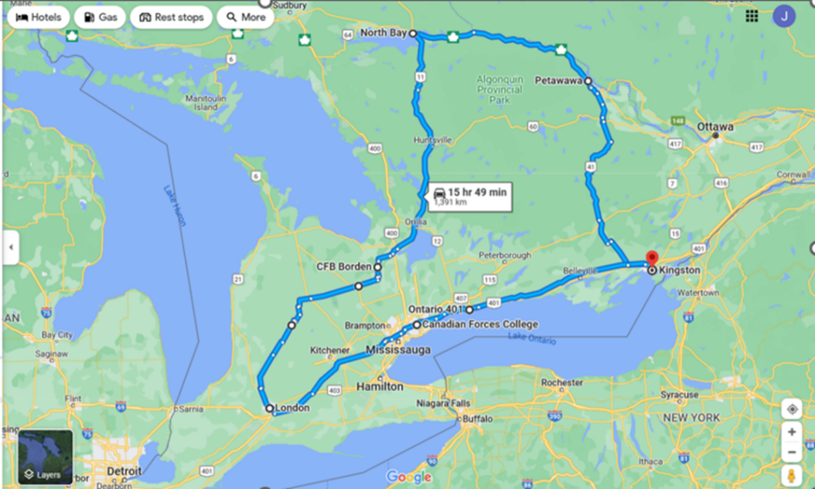
List of Activities Since the last NE Meeting
- May 2-3 – RCAF L2 UMCC, Winnipeg, MB
- May 13 – Canadian Defence Academy (CDA), Kingston, ON
- May 14 – Canadian Forces Health Services (CFHS) L2 Mtg, Virtual
- June 2 – RCAF L1 UMCC, Ottawa, ON
- June 17 – GLMC, Ottawa, ON
- July 3 – NHSPC meeting, Ottawa, ON
- July 7 – Began acting assignment as UNDE Executive Vice-President
- July 9 – LRO Standing Meeting, Virtual
- July 14 – National defence Fire Service (NDFS) Wellness Committee, Virtual
- July 17 – RPOU Ontario UMCC, Toronto, ON
- July 18-19 – PSAC Ontario Regional Council, Toronto, ON
- July 28 – Interview #1 for National Political Action Officer
- July 31 – Interviews #2-3 for National Political Action Officer
- August 1 – Interview #4 for National Political Action Officer
- August 5 – Interview #5 for National Political Action Officer
- August 5 – Meeting CFB Kingston, Kingston, ON
- August 13 – LRO Standing Meeting, Virtual
- September 1 – Labour Day Parade, Kingston, ON
- September 4-7 – UNDE Ontario Regional Conference, Huntsville, ON
- September 8-9 – UNDE FR Steering Committee Meeting, Ottawa, ON
- September 10 – LRO Standing Meeting, Virtual
- September 10 – Interviews #1-2 for Communications Officer
- September 11 – Interviews #2-3 for Communications Officer
- September 15 – Handover with EVP
- September 17-19 – NHSPC Meeting, Ottawa, ON
- September 25-28 – PSAC National Health and Safety Conference, Toronto, ON
- October 8 – UNDE Local 00650 Financial Meeting, Trenton, ON
- October 14 – RCAF L2 UMCC, Virtual
- October 15 – AGMs: Locals 00619, 00620, 00621, Borden, ON
- October 16 – RPOU Ontario UMCC, Toronto, ON
- October 24 – Alternate Dispute Resolution, Kingston, ON
- October 27 – AGM: Local 00650, Trenton, ON
- October 28 – AGM: Local 00641, Kingston, ON
- October 29 – AGMs: Locals 00629, 00639, Petawawa, ON
- October 30 – AGM: Local 00635, North Bay, ON
- October 31 – Travel to Ottawa, ON
- November 14 – RCAF L1 UMCC, Ottawa, ON
- November 16-21 – Ontario Federation of Labour (OFL) Convention, Toronto, ON
- November 25 – AGM: Local 00625, Toronto, ON
- November 26 – AGMS Local 00649, Toronto ON and Local 00637, Trenton, ON
- December 1 – Travel to Ottawa, ON

UNDE Portfolios:
UNDE Standing Bylaws
Health and Safety
Return to Work
4th Canadian Division Support Group
Real Property Operations Unit (Ontario)
ADM (Mat) Group
Materiel Support Group
Royal Canadian Air Force (RCAF) L1 and RCAF L2
CMP/MILPERSCOM
CFHA Central
CFHA Eastern

Regional Highlights:
It has been yet another busy time in the region (as highlighted above). Since the last reporting period, UNDE Ontario members have been involved in a number of events. UNDE Ontario held a Regional Conference, PSAC held a National Health and Safety Conference, and the Ontario Federation Labour held its biennial convention. Locals continue to work on their plans for member engagement, with some festive events being planned for this holiday season.
Treasury Board Strike discipline for the region has finally wrapped up and all reports have been finalized, and the PSAC has sent out final letters to all identified scabs. This has been most welcomed news to affected Locals.
President of Local 00623, and Regional Human Rights Coordinator, Mandy Forgét, continues her work on the PA Group bargaining team. She is an invaluable asset to the team and UNDE members can feel very confident with her at the table.
Local 00639 is currently in bargaining. The employer, Dexterra Group, has not been bargaining in good faith and continues to delay the process. PSAC has filed for conciliation as a result of inaction at the bargaining table.
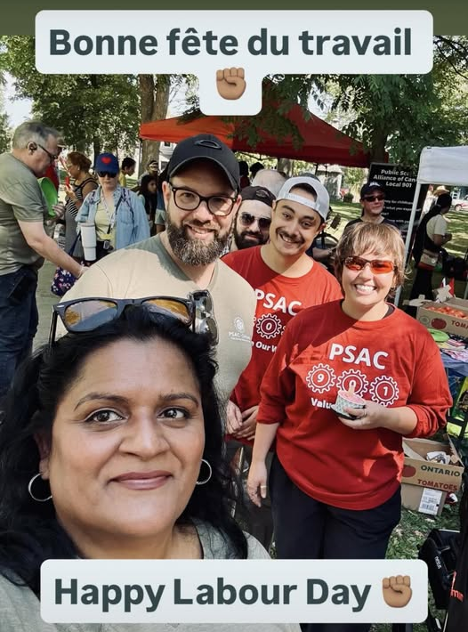
Photo: Labour Day in the Park and Parade, Kingston, Ontario, September 1, 2025.
The UNDE Ontario Regional Conference 2025 was a great success. There was a mix of new and familiar faces in attendance. 5 UNDE Young Workers attended the event, which was great for sharing information and a variety of perspective.

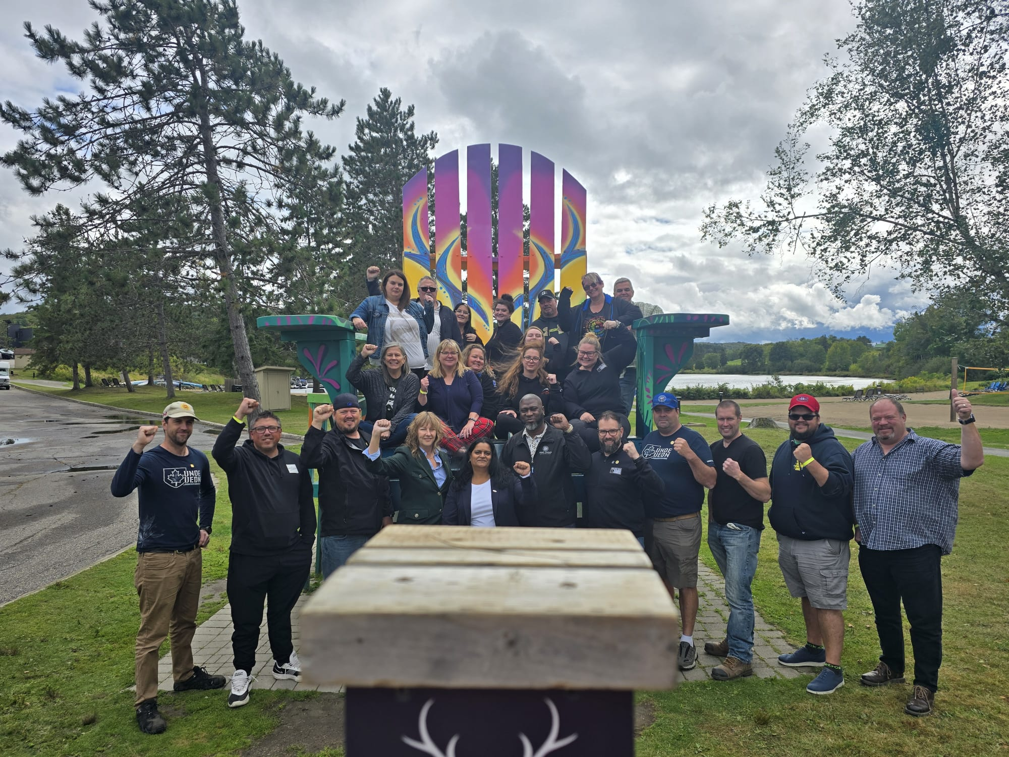
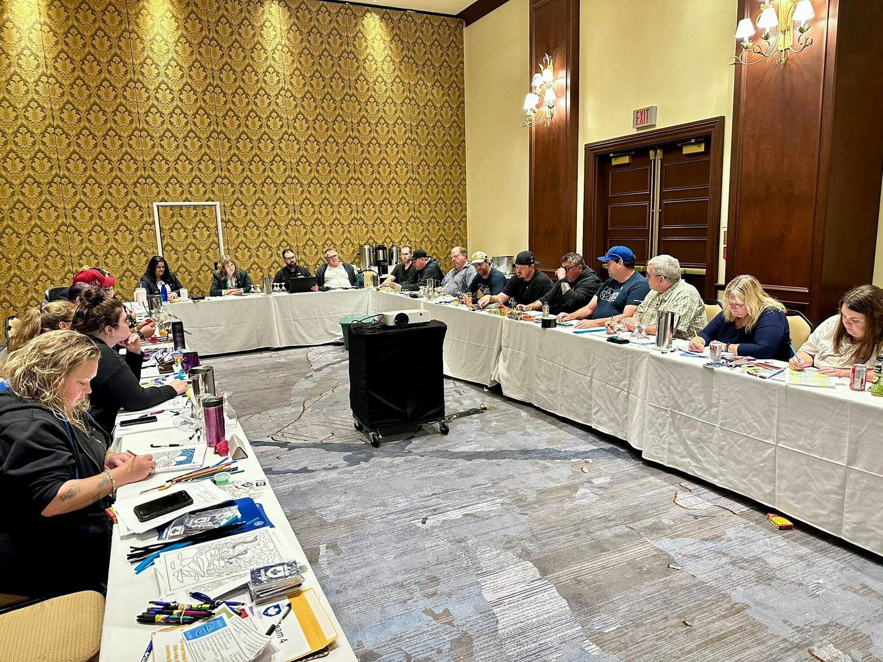

Photos: UNDE Ontario Regional Conference 2025, Deerhurst Resort, Huntsville, Ontario, September 5-6, 2025.

UNDE education across the Region has been well attended and very successful. Participants have been impressed with the facilitation and course content.
All 12 Ontario Locals have registered a Young Worker for the upcoming 2025 Young Worker Conference. This will be a fantastic opportunity to grow the movement and to create a more robust network of UNDE Young Workers. UNDE Ontario Regional Young Worker Representative, Tiffany George, has created a regional chat group and continues to expand the Ontario network. She also spoke at the UNDE Ontario regional Conference as well as 2 AGMs in Borden, ON.

Though the circumstances were not ideal, I had the privilege to serve as acting UNDE Executive Vice-President from July to September. It was an incredible opportunity and one I did not take lightly. Below is a non-exhaustive list of my activities during this period. I continued to hold all portfolios assigned to me as VP Ontario, while DVP Ontario, Chris Snooks, took over the portions of the role that could be delegated.
Acting Period Activities: July 7 – September 15, 2025
- Onboarding of LRO Staff for UnionWare Case Module
- UnionWare Training for LROs
  - Guided and Self-Paced Available
  - Email sent to LROs including training schedule
- Civility Training for all Staff
  - Scheduled for October (TBD based on availability)
  - In-person with Lise and Gabriel
- Coaching Sessions for a staff member with Lise from Delphi
  - Emailed member to ensure he took part in the sessions
  - Member made contact with Lise and sessions are being scheduled starting in October
- Staffing Process Completion – National Political Action Officer
  - Vetted Short-List of Candidates
  - Participated in Hiring Board and Selection Process
- Staffing Process Completion – Communications Officer
  - Vetted Short-List of Candidates
  - Participated in Hiring Board and Selection Process
- Authentication Token Distribution and Implementation for all Staff
  - Eliminates the need to use personal cell phone to access VPN
- NDFS Wellness Committee
- FR Steering Committee Meeting
- COMTRA
  - Regional Education Plans
    - Reminder Email Sent
  - UNDE Mod Amendments
    - Mona is preparing them after having facilitated the new mods
  - Human Rights Module Creation
    - National Political Action Officer to be responsible for module creation
  - Updated Facilitator List
    - Some regions have provided feedback
- CDA LMCC
  - Feedback solicited on Proposed ToRs
  - Co-chair still required
- Pay Issues (Various)
- NBoD Special Meeting – WFA Strategy
  - Attended for June
- NBoD Ad-Hoc Committee: NJC Relocation Policy
  - Attended for June
- LRO Monthly Meetings
  - July, August, September
- QC Region Education – November 2025
  - Assigned a Facilitator
- Bagotville Staffing Issue
- Document Retention/Life-Cycling
  - Physical Files Converted to Digital
  - Closed Physical Files Older than 2 Years Shredded
- Liaised with PSAC NP concerning UNDE Member TM (NCR)
- Addressed informal complaint received concerning a Local President
- National Office Network Outage Mitigation
- Approved PurelyHR Requests
- Covered for National President during her Vacation (3 weeks)
- Prepared for Media Interviews x 2

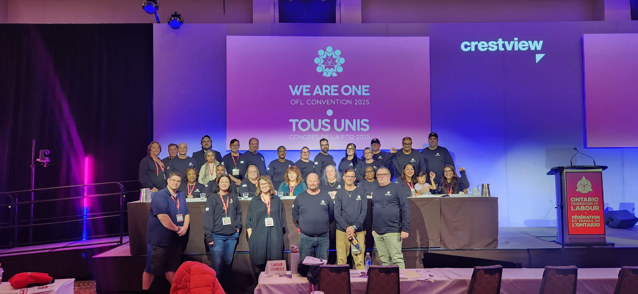
Photo: UNDE Ontario members at the Ontario Federation of Labour Convention, November 16-21, 2025.

As always, it continues to be a very busy time across the UNDE Ontario Region. I continue to encourage Locals to participate in events as they take place. Education opportunities have been made available to all Locals and much work has been done to have PSAC Ontario deliver training to our members wherever a need exists.

Additional Regional Initiatives
Staffing Issues tracker
Local Portfolios Database
Participation and Retention Tracker
Education (Fall/Spring Schools)

Respectfully submitted,

James Potts
Vice-President – UNDE Ontario Region
Alternate UNDE Executive Vice-President

