ROYAL CANADIAN AIR FORCE RCAF L1
UNION MANAGEMENT CONSULTATION COMMITTEE
Report to the NE meeting April 2026

Last meetings held 14 Nov 25. Next meeting scheduled for 29 May 26.
Comd RCAF LGen Jaimie Speiser-Blanchet, DComd RCAF MGen Denis O’Reilly
1 CAD -1 Wing Kingston, 2 Wing Bagotville, 3 Wing Bagotville, 4 Wing Cold Lake, 5 Wing Goose Bay, 8 Wing Trenton, 9 Wing Gander, 12 Wing Shearwater, 14 Wing Greenwood, 19 Wing Comox, 22 Wing North Bay, ATESS - Aerospace and Telecommunications Engineering Support
2 CAD -15 Wing Moose Jaw (2 CFFTS, 3 CFFTS, 431 Sqn), 16 Wing Borden (CFSATE, CFSACO, RCAF A), 17 Wing Winnipeg (CFSSAT, Barker College, 402 Sqn, RCAF Band, Det Dundurn), 2 CAD HQ (CFASC)
3 Canadian Space Division Commander - 7 Wing, 3 CSD HQ

FAcT Update- follow-up to outstanding action item from the previous minutes, confirming that Comd 2 CAD was to initiate a meeting with the union representatives no later than the summer of 2025.
At the Nov 2025 meeting, UNDE confirmed that no meetings with the UNDE have taken place with FAcT SME, the Operational Implementation Working Group (OIWG) or at the L2 level, despite discussion and requests made at several RCAF L1 and L2 UMCC meetings. UNDE is looking to determine if Public Service (PS) employees were or are being considered in the planning of FAcT, as the decision making and planning process has not been transparent for the Union.
MGen O’Reilly stated he did not believe the Union was given permission to talk to FAcT. He noted his experience with the FAcT program and offered that this indicated a larger issue surrounding the HR planning of many future RCAF and CAF modernization projects. MGen O'Reilly also stated that in his experience as a Commander of a base with contracted support (15 Wing Moose Jaw), that it can be a successful option when compared to hiring public service employees.
BGen Robidoux noted that it is also difficult for FAcT planning staff to provide the background information Ms. Simcoe is seeking because they are not the project decision makers.
Ms. Simcoe indicated that sharing information is key when facilities maintenance projects are being consider which are excluding public service positions. Mr. Potts agreed. Ms. Simcoe requested that consultation with the FAcT staff still need to occur, and that the RCAF answer the following questions:

1. What is the current policy with respect to HR planning for contracts like FAcT, specifically the choice between public service employees and contractors? a. Is there any policy that directs the level of consultation between L1s and their respective unions in the early stages of HR planning?
b. If not, is there a plan to develop one?

2. Given changes to funding levels and predicted growth of the RCAF public service, has a business case analysis been done to challenge the cost effectiveness of contractors vs public service employees?

3. Is there a policy that does/does not direct how in-service support contracts are drafted in the future?

4. Are there plans to upskill particular public service employee positions as part of RCAF modernization projects? a. Is there a list of identified capabilities that the RCAF is planning to abandon? (ex. RP Ops capacity building)

MGen O’Reilly and Ms. Simcoe agreed that a response from the RCAF would be provided by 31 Jan 2026 to the above questions. They also highlighted that these questions need to be brought up at the NUMCC on 3 Dec 2025. To date a response has not be provided and UNDE has not asked for a follow up.

Contamination Environmental Concerns –
The most recent information obtained regarding 15 Wing Moose Jaw is from a work refusal made on 15 Aug 25 concerning the contamination of Building 143, and the danger the contamination poses to members health and safety. The decision of the Health and Safety Officer - Cathy Corbett
Official Delegated by the Head of Compliance and Enforcement confirms the decision of absence of danger. The employer will, as required by subsection 145(5) of the Canada Labour Code, Part II, cause a copy to be posted in a place accessible to all employees and give a copy to the health and safety committee for the workplace.

The Designated Substances Survey Report – Subject Building dated March 3, 2025, and the Contaminants of Concern Exposure Assessment Report dated March 12, 2025, tested for chemicals that pose a danger. All levels were below the Occupational Exposure Limit (OEL); there was no known substance that exceeded the OEL. The PFAS Investigation Report – Select Areas dated March 13, 2025, assessed many chemicals, and there were no concerns. The levels of the PFAS were low, and not dangerous.

FTE Staffing Vacancies and SWE Overview
RCAF Growth –
Nov 2025 UMCC
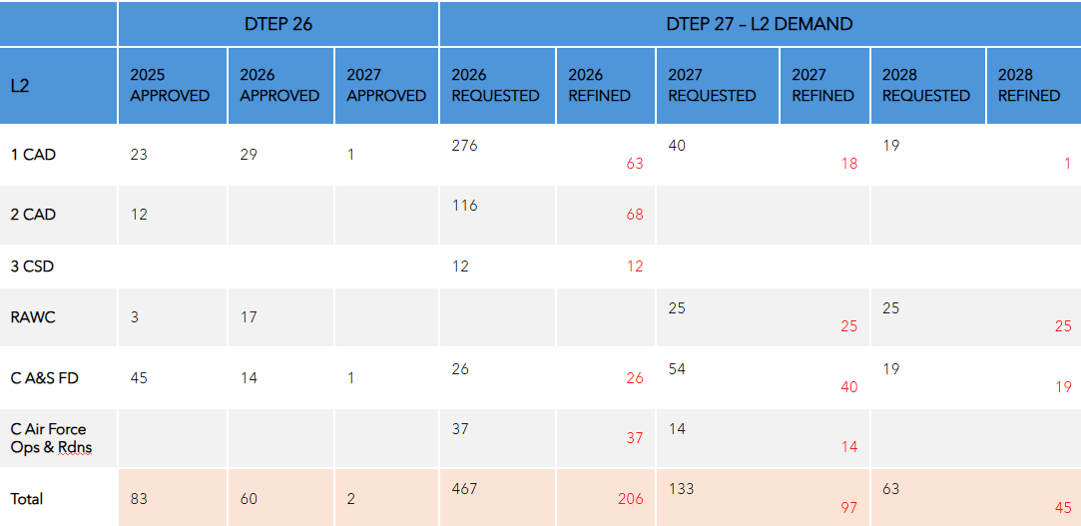

Defence Team Establishment Plan (DTEP)
Investment and Resource Management Committee (IRMC)

From the Printed Nov 2025 minutes the RCAF is set to grow in the coming years, specifically highlighting DTEP IRMC funded growth approved through DTEP 26, as well as future growth requested through DTEP 27. They shared that DTEP 27 demands had not been endorsed by Comd RCAF at the time of this meeting. This does not encompass the complete growth within, as there are other sources of funds supporting indeterminate growth within the RCAF.

Respectfully Submitted by
Mona Simcoe Co-chair VP MB/Sask & James Potts VP Ont

