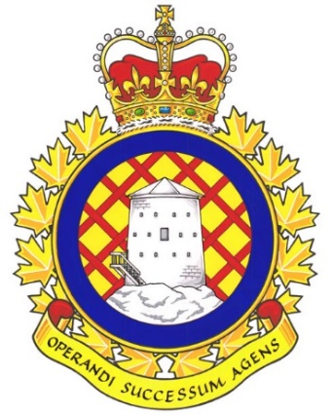

Real Property Operations Unit (RPOU) Ontario Report

There have been 2 UMCC meetings since the last NE meeting. They were held in January and April 2026.

UNDE members on this committee include:
Brian Duck, Local 00621 Borden
John Dean, Local 00625 Toronto
Jason Jones, Local 00629 Petawawa
Nate Buisman, Local 00635 North Bay
Cheryl Gough, Local 00637 Trenton
Chris Snooks, Local 00641 Kingston
James Potts, Co-Chair

RPOU Ontario HQ
The Headquarters will be moving to Kingston, ON in the very near future. This will not result in any UNDE members being workforce adjusted or forced to relocate. Members will be permitted to work remotely and/or from their current workplace. Additional positions will either be hired for under the same arrangement or be hired locally in Kingston.
Vacancy Management, SWE, and O&M
Vacancy Reports continue to be provided at regular intervals without the need to make a request. These reports serve as the benchmark when making requests from other parts of the DND organization. It is a standing item and is produced by the committee secretary every few months. Staffing is expected to fill some many vacant positions across the organization in order of priority. The SWE allocation for this fiscal year is considerably higher than it was last year as a result of the government’s commitment to increase defence spending. There is significant growth forecast for Ontario RPOU Detachments over the next 7 years, with the majority of positions being created and/or filled over the next 4. CO RPOU Ontario has instructed all detachments to go ahead immediately with the first 4 years’ worth of staffing actions. O&M has also increased, and preventative maintenance is now being performed across the region.
Multi-Trade Pools
These pools have been established but they are not working very well. This is due to a mismatch between available positions and the location of qualified candidates. The disparity between private and public sector wages is also a major roadblock for certain trades. Positions will also be advertised at job fairs and other avenues, but these positions will also all be officially advertised on www.jobs.gc.ca.
Training and Education
There is available funding for training and education, and it is strongly encouraged to take advantage of this opportunity to maintain, sharpen, or learn new skills. Health and Safety education is also being promoted.
Real Seal
The CO of RPOU(O) has agreed that the Red Seal will remain the standard and that individuals who possess a Red Seal will be hired before anyone who does not hold that qualification. Conditional staffing offers are an option.
RPOU(O) is in the process of increasing their use of the apprenticeship program as well in order to assure that there are sufficient candidates for the positions available.
Self-Help
The issues related to self-help are all related to units taking on projects without following the policy and/or contacting their respective RPOU Detachment. A wall at 8 Wing Trenton was cut into and potentially asbestos containing material (ACM) dust was created, putting people at risk. More information is being gathered on this incident.
CORCAN
RPOU Det Kingston has increased its use of CORCAN in lieu of other contractors. They do not permit high-risk offenders or those convicted of violent crimes to be on base property. As such, this provides soon-to-be-released inmates with the opportunity to learn some job skills and ease in their reintegration into society. CORCAN is not being used to replace any of the work currently being performed by our members.

Force Expansion Initiatives
With the planned increase in CAF recruitment, there is an increased need for housing. UNDE continues to demand that any new construction avoid facilities management contracts and that all cleaning and maintenance be the responsibility of RPOU and performed by our members.
Water Quality and Legionella Testing
Water tests are conducted throughout the year. In most instances, municipal water is being used and is tested by the municipality up to the point where it enters Base/Wing lines. The issues generally arise from old pipes in DND’s aging infrastructure. Testing results where lead or other hazardous materials have been detected will be shared with UMCC members.
Legionella testing of standing water and pipes is ongoing. This stemmed from an incident in Kingston, Ontario, where a member contracted Legionnaire’s Disease after working in an area with standing water in the basement of a DND building. This initiative is now province-wide and is supposed to expand nationally.
Contracting In
Grass cutting in Kingston is to return to the Public Service. DVP Ontario, Chris Snooks, was the catalyst for this. Equipment has been ordered and the current contract is being cancelled. This is a significant victory, and the same initiative will be pushed to other Bases/Wings.

The next meeting of the RPOU Ontario UMCC is scheduled for June 2026.

Respectfully submitted,
James Potts
Vice-President – UNDE Ontario Region
Alternate UNDE Executive Vice-President

