RP Ops Pacific
ODM “Office of Disability Management” has provided a power BI with some statics, Unfortunately is miss leading, the date range is from April 2017 – March 31, 2026. Please attached PDF File.
As of April 8, 2026, with the opportunity funding “Surge” Progress for region we have a total of 154 Positions to be approved.
Addi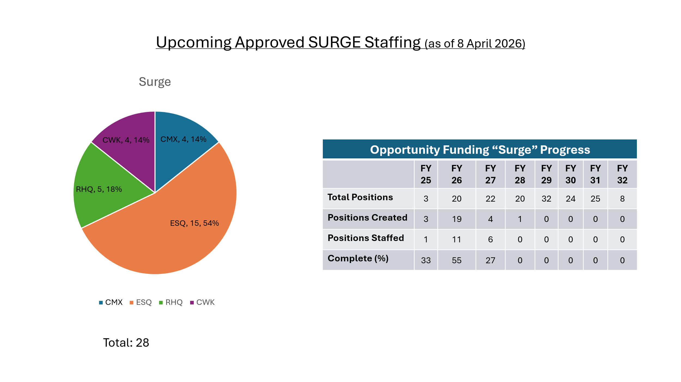
Additional recent approved staffing:
  - ESQ - 29 Indeterminate, 4 term positions, 1 Acting Appt, 1 Acting Ext, 1 Reclass (including 1 new position creation)
  - CMX - 6 Indeterminate, 3 term positions, 1 Acting ext (including 1 new position creation)
  - CWK - 2 Indeterminate positions (including 1new position creation)
  - RHQ- 4 Indeterminate positions, 1 Acting Appt (including 1 new position creation)

RPOU(P) Staffing Points – April 2026
Staffing Actions:
· From 1 April 31 March 2026, Pacific completed 110 staffing files (not including Acting under 4 months, casuals or students). This was a 19.6% increase over last year. 22 new position creations.
· As of 8 April 2026, Pacific has 81 approved staffing files on the rolling list, 28 of which are new surge creations.
· Last Fiscal Year, we completed a total of 92 staffing files.
(Breakdown by type of staffing action and Sect/Det can be found in the Presentation)
SWE:
FY 26/27:
Allocation: $25,493,896
Current Forecast: $29,311,137
14.97% over allocation ($3,817,241)
*Comd approved Pacific to over-plan to 30%

FY 25/26:
Allocation: $24.4M
Current Forecast: $24,502,439
0.42% over allocation ($102,439)
Attrition:
Attrition from 1 April 2025 – 31 March 2026: we have had a total of 17 employees who have retired/resigned (7 CMX, 8 ESQ, 1 CWK, 1 RHQ). We are tracking potentially 2 additional retirement before the end of the FY (CMX, RHQ), and 3 additional next FY (1 CMX, 2 ESQ). Past retirement data from HR-Civ (Retirement Dashboard - Power BI):
The Base, RP Ops and other lodgers unites are holding a job fair in hopes to attract new hire, it has been hard to staff new trades do to the lower wages compared with other employers.
Comox Heating Plan staff, Union and management had a meeting to discuss the ongoing issues with new boilers installed that do not meet specifications, our members exercised their right to refused to work until the work is completed and all issues are solved, management agreed and they are working in doing the proper work. I asked the question regarding FM Contracting for these two heating Plans, at this time both plans are fully staffed, and they have no intentions to contract out this work.
Two new appartement buildings have been purchased by RP Ops and CFHA, one is in View Royal close to Esquimalt, it has 37 unites and will be maintained by CFHA, 7 unites already are occupied, the other is in Comox/ Courteney and it has 52 unites and will be maintained by RP Ops, this one is for the military personnel to stay when on training.

Corcan was part of the agenda once again, and I raised concerns that it seems they are always looking on ways on how to contract work out, I further brought concerns that with all the extra funds that we are receiving, they are not being watchful on how they are going to spend and not making any business case to see if having work done in house is cheaper then contracting out, and where the money can be better spent.

Respectfully submitted by
RVP BC
Marcelo Lazaro

