ADM Infrastructure and Environment UMCC
ADM(IE) UMCC
Report for the National Executive meeting April 2026

ADM(IE) UMCC last meeting held on 14 Nov 25. Next meeting is tentatively scheduled for 29 May 26.
ADM(IE) Peter Hammerschmidt, MGen Nicolas Pilon, COS(IE) and Col Fortin Comd RP Ops Gp HQ.

Agenda Items:
Update on establishing a RP Ops Group Health and Safety Policy Committee. Col Fortin will give update at next meeting but noted there is only one DND Policy committee on Health and Safety, all others are an advisory body to manage locally groups of more than 300 employees. Currently, ADMie is tracking that each detachment has a H&S committee or a H&S responsible officer when there are small teams. At the Formation level, it is a management body to implement and to align compliance.

Update on Red Seal requirements. An external advertised job posting for a national application process stated applicants with QL5 qualification “may” be asked to obtain a Red Seal. UNDE has always stated the wording is “shall”. UNDE’s understanding was that ADM(IE) was not going to accept QL5 as a Red Seal equivalent. UNDE can accept conditional appointments where obtaining a Red Seal is a requirement within a specified timeframe, but not as an equivalent to a Red Seal.
LCol Fortin reviewed the wording in question and confirmed the intent and practice remain fully aligned with applicable provincial and territorial regulations. The language currently included in the poster was designed to remove unnecessary barriers at the application and screening stage for Canadian Armed Forces (CAF) members who possess a valid Technical Qualification Level 5 (QL5). This approach allows military applicants with recognized equivalent training and experience to be considered within the pool, particularly given that provincial recognition pathways may vary across jurisdictions. Lcol Fortin then stated to ensure full compliance with conditions of employment and regulatory obligations, CF RP Ops Gp will formally direct HR-Civ, Regional Command Teams and Hiring Managers to consider only a valid Red Seal certification as the recognized trade qualification for appointment to positions where such certification is required. QL5 qualifications or other equivalent military credentials may be used solely to support eligibility at the screening stage but will not be accepted as a substitute for the required Red Seal certification at the time of appointment. All appointments will be contingent upon the candidate holding, or formally obtaining within the prescribed timeframe where permitted, the appropriate Red Seal certificate in accordance with established conditions of employment regulations. Therefore, all future posters will have a ‘SHALL’ instead of a ‘MAY’.

DCC Service Level Agreement or Memorandum of Understanding has been requested for UNDE review.
At the last meeting Col Fortin stated there will be more Facility Management contracts.
The Plan
Work Force Investment
- All domain increase (incl. Shops)
Maximized Ops Delivery
- Facility Maintenance Contracts, Project Management, Contracts
Maximized Project Delivery
- Construction Management, Modified-Design Build, Design-Bid-Build and Technical Support Services
All Tools On Hand Approach
- DCC
- PSPC
- CORCAN
- Delegations

Quality control of contractors is crucial for workforce. With the influx of $9B funding, there is a pressure to spend quickly on infrastructure and a need for projects to be ready, so at the front end, will require contractors; expect contracting support to decrease as hiring increases. Staffing takes time, so DCC is essential at this stage. There has not been consistent funding, but with this, the team can plan 5-10 years in the future. Extra DCC services are needed for project management and contract management to deliver better infrastructure and fix the foundation (state of the portfolio).

There is not enough SWE & FTE so transforming portfolio into increasing capacity, delegations of authority, and using all the tools which means contracts and DCC.

Unions secured a separate meeting (which has not happened to date) to receive clarity on the mandate of DCC and discuss stop using DCC for work outside of its mandate. The Service Level Agreement (SLA) handbook and contracting authority regulations need to be followed. This meeting will also talk about quality control and holding DCC accountable.

SWE/FTE update:

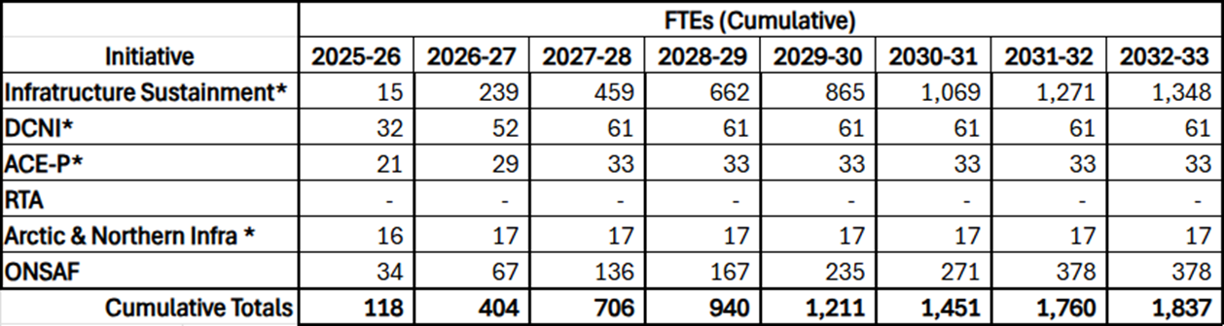

* Incremental FTEs earmarked (2026-27+), pending final Treasury Board decision.
Note: Additionally – not listed here:
- $10M in SWE secured through DND’s Investment and Resource Management Committee (IRMC) to address CF RP Ops Group staffing shortfalls.
- NORAD Modernization funding, which includes projects sponsored by other L1s and supported by ADM(IE) ~198 FTEs.

CF RPOPs Group ReOrganization
Executive Summary
- 10x J-Heads consolidated into 3x Directors: Operations, Programs, and Support
- Primary Aim is better integration with other ADM(IE) L2s – many are unfamiliar with J-Code structure
  - Currently other L3’s have between 2-5 contact points within the J-Codes, new structure provides one primary POC for each L3.
- Secondary benefit is improved depth and focus as well as maximizing existing senior leadership in the HQ
  - Example: Program Management is currently shared between 3x J-Codes that would consolidate under one.
- Execution achievable within months, anticipated to be relatively seamless. Prioritized within current ONSAF FTE forecast.
- Civilian Director planned for Program – creates continuity and development benefits, but classification risks (AS vs EX)

New Structure at a Glance

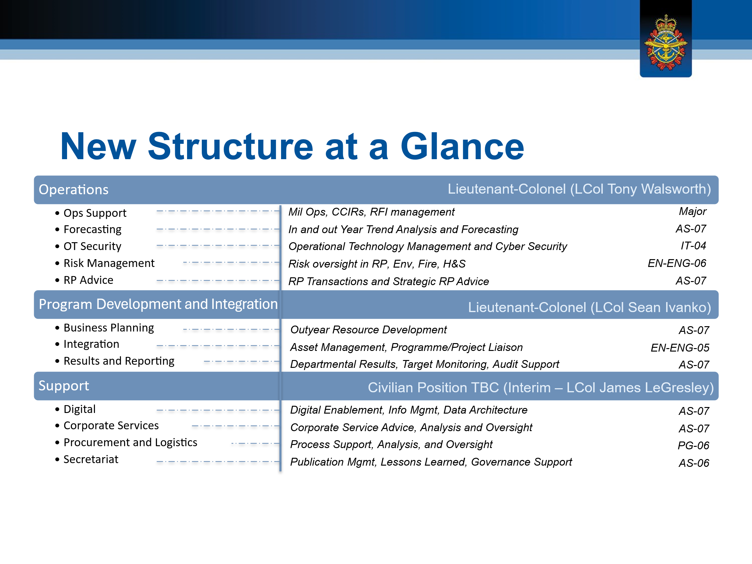
2026 is the 10th Anniversary of Real Property Centralization

Respectfully submitted by
Mona Simcoe Marcelo Lazaro
VP MB/Sask VP BC
Co-Chair

