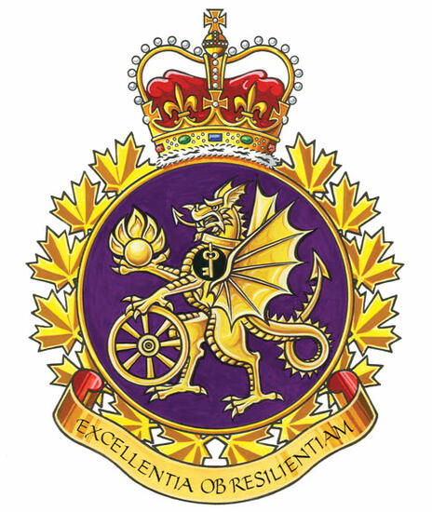

ADM (Mat) Group Report

The ADM (Mat) UMCC (GLMC) was held on January 16th, 2026.
Management Co-Chair Ms. Nancy Tremblay and Labour Co-Chair Mr. Adam Gray.

Parking
Parking for members working at the National Printing Bureau continues to be an issue. We continue to work with local and divisional management on improving the local parking situation. How they're going to accommodate up to 150 more staff at NPB, with the eventual move of staff from 975 St. Joseph blvd in Gatineau, remains to be seen. To date, no permanent solution has been found, though a shuttle service has been implemented. Any increase in return to office policy will only compound the situation.

Health and Safety
Concerns have been raised that some subordinate units do not have functioning Health and Safety Committees. Management has identified the challenge as being one of geography. ADM(Mat) group members are spread out over several buildings. In some cases, it makes sense to have a meeting that is exclusive to that group, and other cases would be best addressed via a mixed committee of occupants within a portion of a particular physical workplace.

There was an asbestos management issue at Major-General Pearkes building. The collaborative actions with CFSG(O-G) Health and safety staff have improved the contractor’s adherence to the Asbestos Management Plan protocols. In particular, employees have now been adequately informed of any work to be conducted that could create airborne particulate containing asbestos and other toxic substances. The proper asbestos abatement protocols are being followed.

Workspace at the Carling Campus
Discussions have taken place with the ADM(IE) regarding the availability of workspace, including at the Carling Campus. He indicated that Public Services and Procurement Canada (SPAC) had also expressed interest, although challenges remain, and confirmed that the previous “campus” concept had been abandoned as it was not deemed viable at the time. The “neighborhood” approach was mentioned as a way to identify groups that should work in close proximity to foster team cohesion. It was emphasized that this work must align with the broader federal initiative to reduce the footprint of workplaces in the National Capital Region (NCR).

Update to Human Resources Planning
There are efforts being made to streamline processes and support spending requirements. Initiatives include: Mobility pathway inventories, Talent management inventory, L1 resume bank. Current human resources efforts include: Optimizing resource alignment, Addressing language profile requirements for supervisory positions in bilingual regions, Managing delays related to security clearances. Staffing priorities include: Increasing the hiring of entry-level employees, Plan for more non-mandatory staffing processes.
A new L2 organization, the Director General – Joint Equipment Program Management (DGJEPM), had been. He noted that the Directorate – Technical Management of Munitions and Explosives (DTMME) and the Technical Quality Testing Centre (TQTC) were transferred to this organization in December. He confirmed that a Unit Identification Code (UIC) had been created to establish the financial structure. Next steps include the cyclical work of the Director – Land Command Systems Program Administration (DLCSPA) as well as the continued definition of joint capabilities. He noted that communications are being maintained to keep employees informed.

Respectfully submitted,
James Potts
Vice-President – UNDE Ontario Region
Alternate UNDE Executive Vice-President

