
Health and Safety Report:
James Potts, Johanne Rouillard, Danielle Poissant, and Steve Warren

The National Health and Safety Policy Committee (NHSPC) held hybrid meetings in December 2025 and April 2026. The next meeting is being scheduled for June/July 2026.
Management Co-Chair: RAdm Christopher Robinson and Civilian Co-Chair: James Potts.

National Health and Safety Policy Committee (NHSPC)
James Potts has assumed the role of Labour Co-Chair for the NHSPC as of April, 2026, where he chaired the meeting. This will allow UNDE to have a greater ability to ensure the committee is operating as it should, and that meetings are being held in accordance with legislative requirements.

Language of Business
The language of business for of the committee and working groups continues to be problematic. Employee representatives have been fighting to have both official languages recognized and given equal import. As such, it was decided that all materials will be made available in both official languages at the same time. This has improved. Simultaneous devices are being explored as an option to allow all participants to participate in the official language of their choice. It has also been authorized for VCDS to pay for travel for Johanne to attend all 4 meetings, as it allows her to participate more fully, though it still does not fully resolve the issue.

Travel
D Safe G and VCDS announced that travel to meetings will be paid for by the Department for 2 of the 4 annual meetings. In an attempt to make NHSPC meetings more predictable and make travel more feasible, moving forward, 4 NHSPC meeting dates were to be set for 2026, each spanning 3-months apart. This has not yet happened. An effort will be made to try and co-schedule the NHSPC meetings with other union meetings such as UMCC. Once the meeting dates for 2026 are set, they will be shared with ADM(HR-Civ) to give them an opportunity to schedule them that same week.
Employment and Social Development Canada – Directions / Refusals
- Work Refusal from MPC (Moose Jaw), Unit: CF H Svcs Gp
  - Occurred on:
    - 18 August 2025
  - Item description:
    - The employee disagreed with the Workplace Health and Safety Committee (WHSC) investigation finding of “No Danger” issued on 9 January 2026.
    - The case was referred to Employment and Social Development Canada (ESDC) on 9 January 2026.
    - The refusal relates to concerns with the physical work environment, specifically the potential presence of PFAS and other volatile organic compounds (VOCs).
    - A supervisor from 23 CF H Svcs C remains in regular contact with the assigned ESDC officer, and all required documentation has been submitted.
    - The ESDC officer has indicated that the investigation, being conducted remotely and desk-based, will take several weeks to complete.
  - Corrective actions taken:
    - The employee has been working from home since the refusal to work was initiated.
    - Multiple sampling activities have been conducted as part of both complaint and refusal to work investigation processes; none have identified or confirmed the presence of contaminants.
    - No further corrective measures have been implemented at this time.
  - Date of compliance:
    - TBD
- Work Refusal from ADM(IE) (Borden), Unit: CF RP Ops
  - Occurred on:
    - 12 January 2026
  - Item description:
    - The employee submitted a refusal to work under Part II of the Canada Labour Code, asserting that entering any building containing presumed or confirmed asbestos-containing materials (ACMs or PACMs) constitutes a danger.
  - Corrective actions taken:
    - On 2 February 2026, ESDC issued a formal written decision under subsection 129(4) of the Canada Labour Code, Part II, determining that a danger does not exist.
    - As a result, the employee is not entitled to continue refusing to work on the basis that buildings may contain ACMs or PACMs.
    - The decision closed the refusal to work file from a regulatory perspective.
    - The employee was informed of their right to appeal the decision to the Canada Industrial Relations Board within the prescribed timeline.
  - Date of compliance:
    - 2 February 2026
- Work Refusal from RCN (MARPAC), Esquimalt, Unit: POESB
  - Occurred on:
    - 14 November 2025
    - Referred to WHSC on 20 January 2026
  - Item Description:
    - The refusal identified multiple issues with the new Naval Large Tug, including inadequate planned maintenance (critical testing not conducted, not adhering to mandatory service and inspections), life-saving appliances out of certification, lack of Engineering Operating Procedures, Lack of technical documents/manuals, and general safety concerns raised but not being addressed.
  - Corrective actions taken:
    - Investigations were conducted between 17 Nov 2025 and 20 Jan 2026, including the member, Branch leadership, the Branch Safety Officer and a member of the WHSEC. Each item in the refusal was reviewed, areas found to have confirmed issues were actioned and rectified or a plan to have them rectified was implemented. It was concluded that the aggregate safety risk that was outlined in this refusal to work no longer exist.
  - Date of compliance:
    - 29 January 2026
- Work Refusal from RCN (MARLANT), CFB Halifax, Unit: Blog
  - Occurred on:
    - 03 February 2026
  - Item description:
    - A related Internal Complaint was initiated July 2025 (to level 2) due to the ongoing concern of birds and droppings in the shop, at which time the corrective measures outlined were to install netting and to have industrial cleaning completed following the net installation. Netting was installed November 2025, and cleaning began January 2026; however, concerns were raised 3 February 2026 regarding improper cleaning practices as the Contractors worked throughout the shop without the proper containment while employees were in the vicinity of the Contractor’s work. Thus, a work refusal was raised and all work in the area stopped.
  - Corrective actions taken:
    - Meeting was held the following week (10 Feb) with PDiv, TEME Maintenance O, the Contractor, WHASC Labour Co-Chair and BLogSE A/Admin (A/USEO was on leave at the time of occurrence). Concerns raised were addressed and mitigation measures were provided by the Contractor including revised cleaning and disinfection procedures, which PMed confirmed effective. Employees continued to work in alternate locations until the cleaning was completed.
  - Date of compliance:
23 February 2026

Acts of Voluntary Compliance (AVCs)

The employer continues to provide the NHSPC with details of acts of voluntary compliance. Recently there have been a number of AVCs for Suffield (3 Can Div).
- AVC from CA (Valcartier), Unit: 2 Cdn Div Svcs Tech
  - Occurred on:
    - 28 January 2026
  - Item description:
    - At the garage of Building 110, employees may be exposed to an A-weighted sound pressure level of 84 dBA or higher for a duration that could be harmful to their hearing.
    - No investigation has been conducted by a qualified person to assess the degree of employee exposure, including all elements required under sections 7.3(4) and 7.3(5) of the Canada Occupational Health and Safety Regulations (COHSR).
  - Corrective actions taken:
    - TBD
  - Date of compliance: 27 Feb: ventilation will not be changed until the exams are carried out. Exam was pushed back to 23rd of March, ESDC confirmed reception of this.
- AVC from CA (Suffield), Unit: 3 Cdn Div
  - Occurred on:
    - 20 January 2026
  - Item description:
    - The AVC identifies sixteen (16) instances of non-compliance with occupational health and safety requirements.
    - Deficiencies were identified in training, workplace committee structure, hazard identification and assessment, workplace conditions, equipment compliance, and emergency preparedness.
  - Corrective actions taken:
    - Action plan was developed; this includes training for employees.
  - Date of compliance:
    - TBD
- AVC from CA (Suffield), Unit: 3 Cdn Div
  - Occurred on:
    - 20 January 2026
  - Item description:
    - The AVC identifies six (6) instances of non-compliance related to confined space management requirements.
    - Deficiencies were identified in confined space identification, assessment, control measures, and procedural framework.
  - Corrective actions taken:
    - Action plan developed
  - Date of compliance:
    - 26 June 2026
- Direction from CA (Suffield), Unit: 3 Cdn Div
  - Occurred on:
    - 11 February 2026
  - Item description:
    - The investigation determined that the employer did not meet regulatory and standard requirements related to the operation, maintenance, and testing of compressed breathing air systems.
  - Corrective actions taken:
    - 11 March: action plan sent to ESDC with a completion date of June 26
    - 13 March: ESDC accepted the action plan.
  - Date of compliance:
    - 26 June 2026

- AVC from CJFC (Montreal), Unit: 25 CFSD, CMSG
  - Occurred on:
    - 22 January 2026
  - Item description:
    - An Assurance of Voluntary Compliance (AVC) was issued to the Department of National Defence (DND) following an intervention conducted at the 25e Dépôt, Longue-Pointe (Montréal, QC).
    - The AVC identifies three instances of non-compliance under Part II of the Canada Labour Code and associated regulations related to occupational health and safety (OHS) governance, committee participation, and incident investigation processes.
    - The local OHS Committee did not conduct the required monthly workplace inspections for the entirety of 2025.
    - The employer has an established practice of appointing an investigator when hazardous situations are reported; however, a member of the local OHS committee is not systematically involved at the outset of investigations, with participation occurring only after investigations have begun or been completed. This is not aligned with paragraph 135(7)(e) of the Canada Labour Code or applicable jurisprudence requiring early and active committee participation.
    - A hazardous situation was reported on 12 January 2026, with follow-up communications occurring between 12 and 16 January 2026. Required investigation procedures under section 15.4(1) (a–c) of the Canada Occupational Health and Safety Regulations were not implemented or could not be confirmed.
  - Corrective actions taken:
    - TBD
  - Date of compliance: TBD

Education and Training in person
Since the pandemic, trainings have been offered online only. D Safe G are looking to reinstate in person trainings especially in sections where computers aren’t available.
The General Safety Program provided training on 1) the Roles and Responsibilities of the National Health and Safety Policy Committee and 2) the Internal Complaint Resolution Process to all committee members. Ad-Hoc Training Sessions will be scheduled and offered on a voluntary basis to provide training for all those who wish to participate. Most trainings have been reformed to the virtual format only. Some trainings will inevitably require in-person modules and those will be offered.

Working Group Updates
- Working Group (WG) on Impairment
- Time frames and deliverables will be established and shared with members on a regular basis, they continue to say that the DAOD process is a very lengthy one, but it should be completed within two years.
- WG on the National Standard of Canada for Psychological Health and Safety in the Workplace
- A contract with a Health Consultant was put in place at the beginning of April, which will in turn help put together a Working Group (WG). A list of 30 names has been submitted for the WG.
- The Working Group will be focusing on the deliverables. Being that this is such as large undertaking, the WG will likely divide the work to focus on various pillars at a time. Updates will be provided to the NHSPC secretarially. No progress to date.
- WG on the Safety Enterprise
- It will be a big focal point to determine who and where all the General Safety Officers are, and to identify all of the gaps that exist in the General Safety structure.

Safety information Management System (SIMS)

Work on the SIMS continues and timelines were shared with the NHSPC. Funding has been allocated to this project until the anticipated completion date.

Defence Safety Program (DSP)
A new program will be designed and implemented to consolidate the 27 existing areas of safety under one united program. Each specialized safety program will still exist on it’s own, but there will be greater oversight and transparency via the DSP.

Hazardous Substance Program
The creation of the Hazardous Substances Advisory Board will coordinate technical guidance across multiple authorities and include safety advisors with hazmat expertise. The Hazardous Materials Reference Application (HMRA) modernization is underway to replace legacy systems.

Conference
UNDE members from across the component participated. UNDE held its National Health and Safety Conference in Halifax, Nova Scotia.

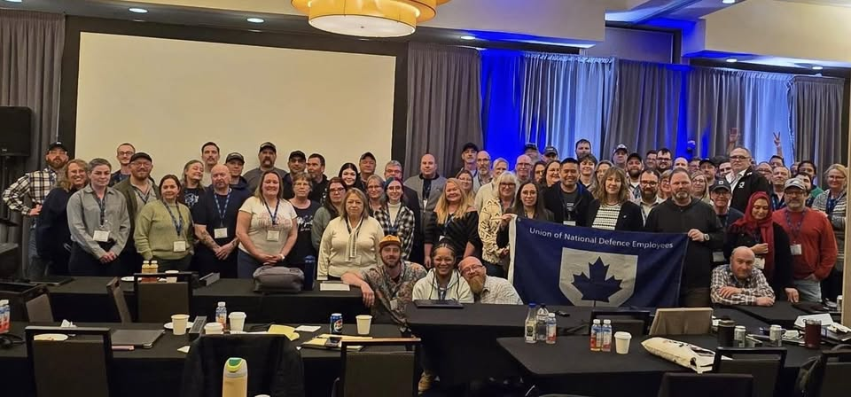
Photo: UNDE National Health and Safety Conference, Halifax, Nova Scotia, April 11, 2026.

Respectfully submitted,

Danielle Poissant, James Potts, Johanne Rouillard, and Steven Warren

