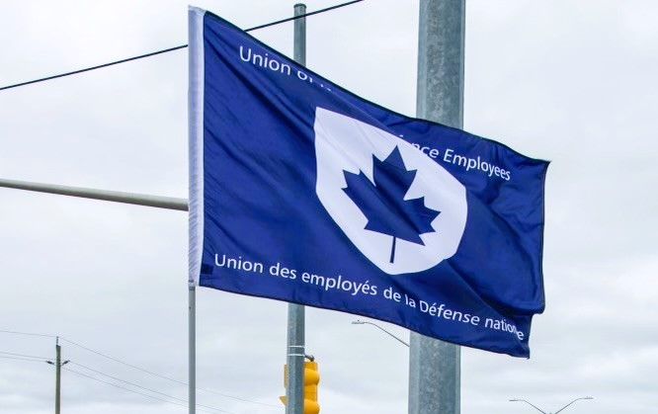
Ontario Regional Report December 1, 2025 – April 27, 2025
VP Ontario: James Potts
DVP Ontario: Chris Snooks
Human Rights Coordinator: Mandy Forgét
Young Worker: Tiffany George
The Ontario region is comprised of approximately 3,500 members across 12 Locals:
00619 Borden, President Neil Creech
00620 Borden, President Christopher Hamilton
00621 Borden, President Brian Duck
00623 London, President Mandy Forgét
00625 Toronto, President John Dean
00629 Petawawa, President Jason Jones
00635 North Bay, President Nathan Buisman
00637 Trenton, President Cheryl Gough
00639 Petawawa, President Chandra Buschold
00641 Kingston, President Chris Snooks
00649 Toronto, President Kevin Hofer
00650 Trenton, President Marc Sisson
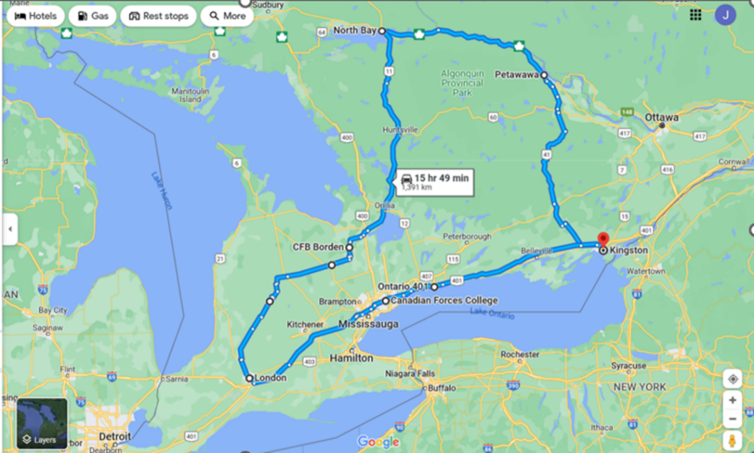

List of Activities Since the last NE Meeting
- Dec 2-6 – National Executive Meeting, Ottawa, ON
- Dec 8 – National Health and Safety Policy Committee mtg, Ottawa, ON
- Dec 10 – AGM Local 00623, London, ON
- Dec 16 – Canadian Military Housing Agency Eastern UMCC, virtual
- Jan 13 – GLMC, virtual
- Jan 14 – Canadian Military Housing Agency Central UMCC, virtual
- Jan 16 – Labour Action for 00639, Mississauga, ON
- Jan 28 – PSAC Ontario RVP mtg, virtual
- Jan 29 – RPOU Ontario UMCC, Toronto, ON
- Feb 26-28 – UNDE Local Presidents Conference, Ottawa, ON
- March 10 – PSAC Investigation Committee, Mississauga, ON
- March 19-20 – UNDE National Young Workers Conference, Québec City, QC
- April 1 – National Health and Safety Policy Committee mtg, Ottawa, ON
- April 2 – Military Personnel Command UMCC, Ottawa, ON
- April 10-11 – UNDE National Health and Safety Conference, Halifax, NS
- April 13 – Royal Canadian Air Force L2 UMCC, Winnipeg, MB
- April 16 – PSAC Investigation Committee, Virtual
- April 17 – PSAC Investigation Committee, Virtual
- April 17 – Real Property Operations Unit Ontario UMCC, Kingston, ON
- April 19 – PSAC Investigation Committee, Virtual

UNDE Portfolios:
UNDE Standing Bylaws
Health and Safety
Return to Work
4th Canadian Division Support Group
Real Property Operations Unit (Ontario)
ADM (Mat) Group
Materiel Support Group
Royal Canadian Air Force (RCAF) L1 and RCAF L2
CMP/MILPERSCOM
CFHA Central
CFHA Eastern

Regional Highlights:
It has been yet another busy time in the region (as highlighted above). Since the last reporting period, UNDE Ontario members have been involved in a number of events, such as the UNDE Local Presidents Conference, the UNDE National Young Worker Conference, and the UNDE National Health and Safety Conference.
A rally was held in support of Local 00639, who was in bargaining with their employer, Dexterra Group. This employer was not bargaining in good faith and that required us to apply pressure. A contract has since been ratified.
Local 00650 has begun approaching members regarding bargaining, which is set to take place later this year.
Locals continue to work on their plans for member engagement, with some outdoor events being planned now that warmer weather has started to arrive.

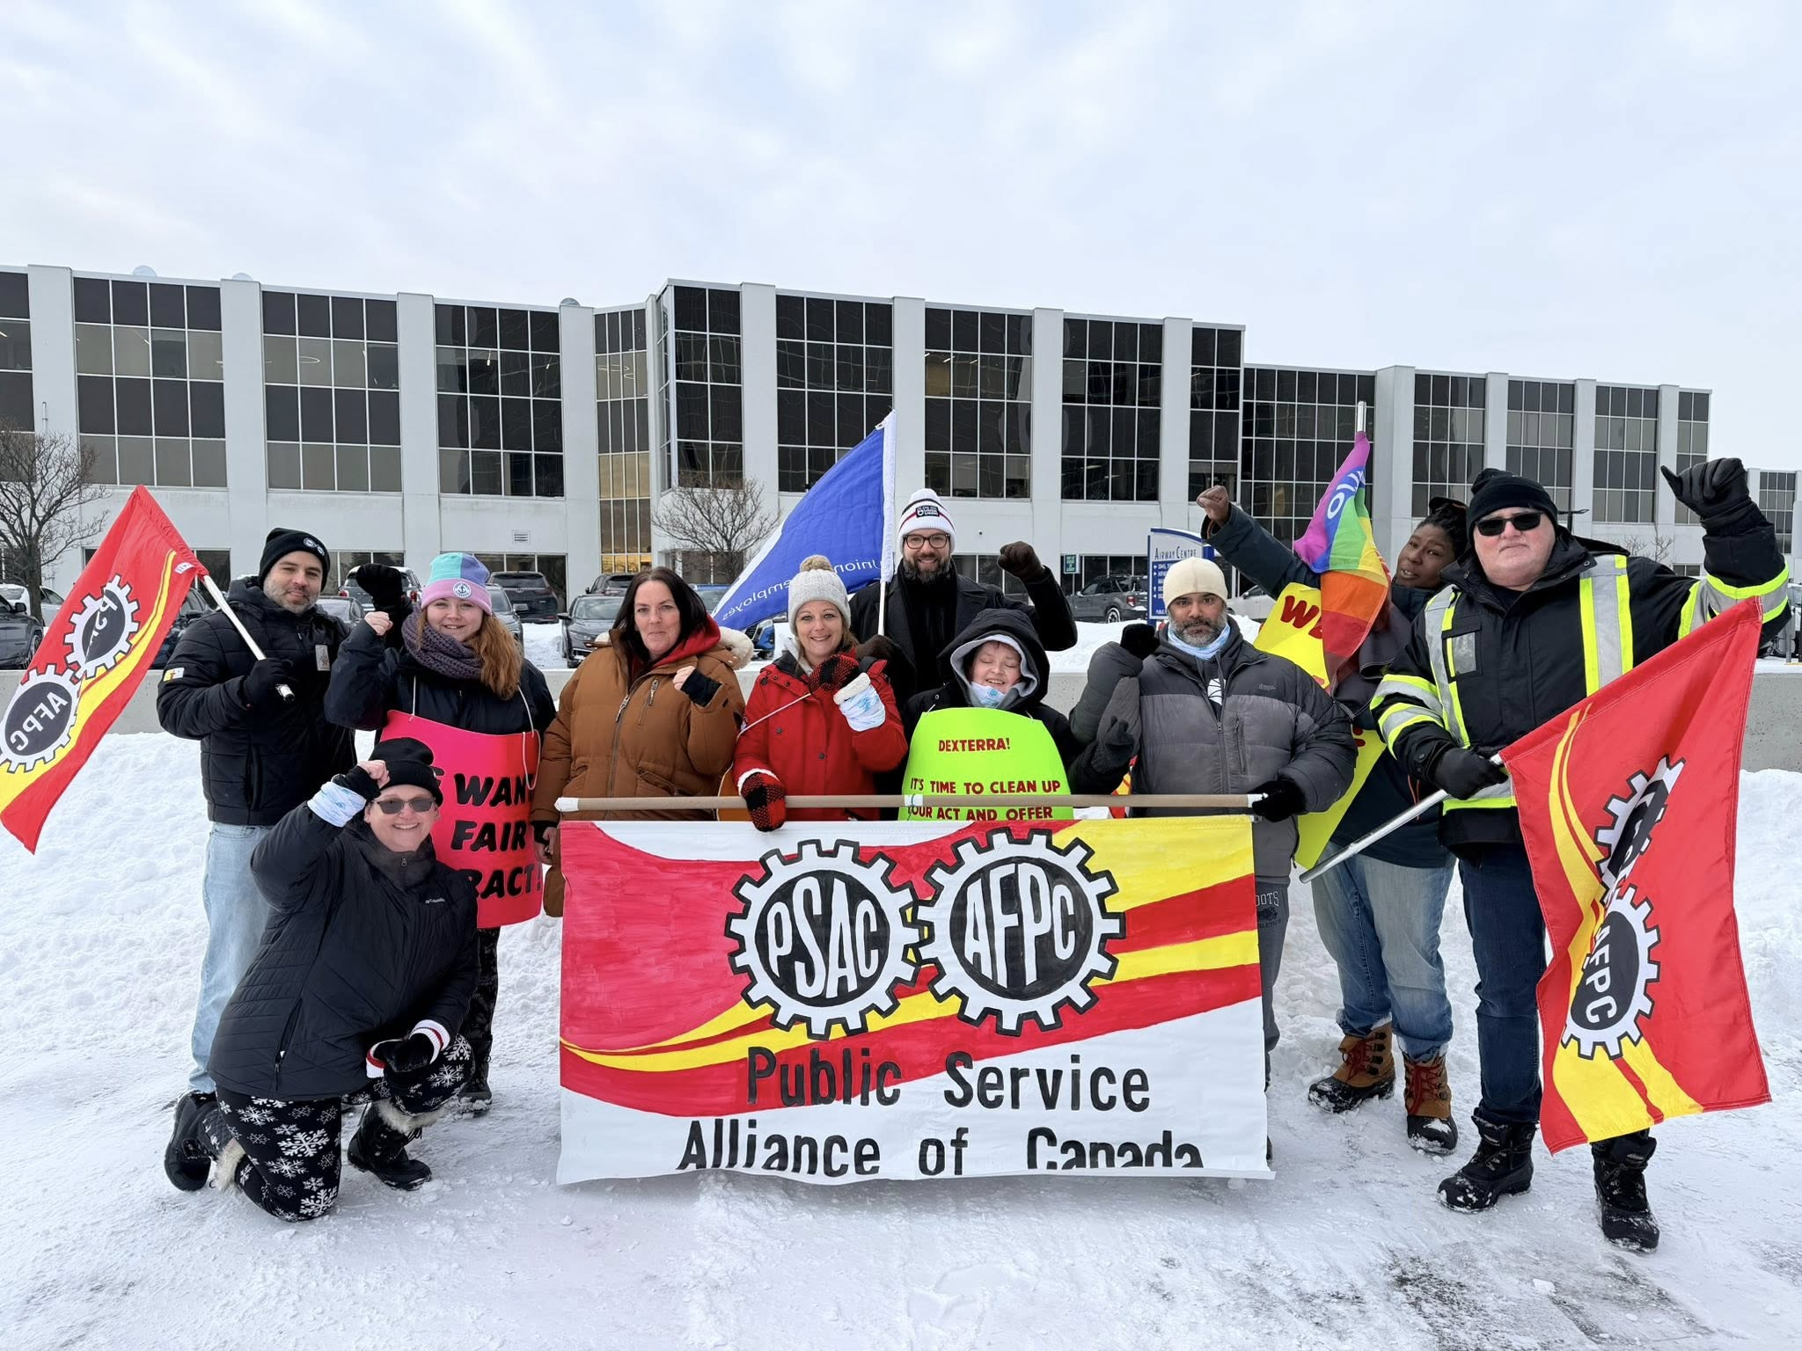
Photo: UNDE and PSAC Rally vs Dexterra Group, Mississauga, Ontario, January 16, 2026.

The UNDE National Young Worker Conference was held in March, and the Ontario region was very well represented. This was a fantastic opportunity to grow the movement and to create a more robust network of UNDE Young Workers. UNDE Ontario Regional Young Worker Representative, Tiffany George, was officially elected at the conference along with Alternate Ontario Regional Young Worker, Christina Nauss. I gave an interactive presentation on Health and Safety that I tailored to address some of the specific challenges that young workers face.

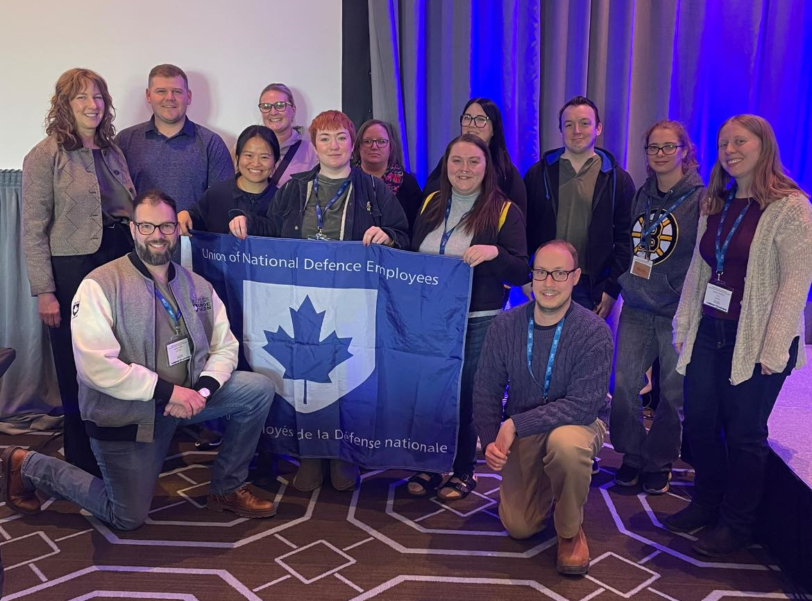
Photo: UNDE Young Workers Conference 2026, Québec City, Québec, March 20, 2026.

UNDE education across the Region has been well attended and very successful. Participants have been impressed with the facilitation and course content. Education opportunities have been made available to all Locals and much work has been done to have PSAC Ontario deliver training to our members wherever a need exists

Non-advertised staffing remains a major concern for the Treasury Board Locals within the Region. Favouritism and nepotism remain serious problems within some units, who seem to act with impunity. We continue to be very vocal at all possible occasions, while also tracking specific instances of questionable hiring and staffing practices.

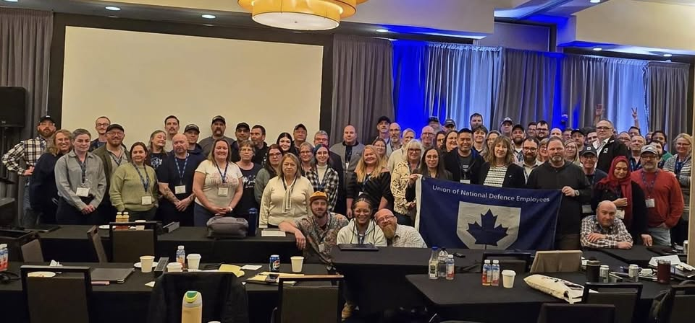
Photo: UNDE National Health and Safety Conference, Halifax, Nova Scotia, April 11, 2026.
I chaired the UNDE National Health and Safety Conference with help from the three other Vice-Presidents who share the Health and Safety portfolio.
It will continue to be a very busy time across the UNDE Ontario Region. I continue to encourage Locals to participate in events as they take place. The battle to stop contracting out and to contract back in remains a priority for the Region. With the increase in Defence spending, this is the ideal time to make gains such as returning work to the Public Service.
The PSAC National Equity Conference will be taking place in May 2026. There will be 5 delegates from the Ontario Region in attendance.
Additional Regional Initiatives
Staffing Issues tracker
Local Portfolios Database
Participation and Retention Tracker
Education (Fall/Spring Schools)

Respectfully submitted,
James Potts
Vice-President – UNDE Ontario Region
Alternate UNDE Executive Vice-President

